

Stéphanie Tuyêt-Hông Pragassam

IRONHACK | DATA ANALYTICS | APRIL 2024

*Understanding Socio-Economic Dynamics in France:*

Insights into Population, Establishments, Salaries, and Gender INEqualitIES

Table of content

Introduction 2

Project Management : 3

High level plan : 3

Project Planning : 3

I. Data sources & Data collection 4

1. Data from flat files 4

2. Data from API 5

3. Data from web scraping 6

4. Data from Big Query 7

II. Data cleaning & Exploratory data analysis 10

1. Data cleaning and wrangling 10

2. Cleaned datasets summary 16

3. Exploratory data analysis & Visualization 19

A. EDA 19

B. Visualization 21

III. Database, ERD, SQL 28

1. Database 28

A. Type of selection 28

B. Database creation 28

C. Entity-Relationship Diagram (ERD) 29

D. Insights from the data collected through mySQL 30

IV. API 35

1. Swagger 36

2. Endpoints 37

A. Endpoint 1 : /population_salary 37

B. Endpoint 2 : /population_salary/<departement_code> 38

Conclusion 39

GDPR 40

References 40

# Introduction

In today's data-driven world advanced analytics, exploring large datasets offers unparalleled opportunities to understand societal complexities. This project dives into the intricate socio-economic fabric of France, leveraging datasets provided by the French National Institute of Statistics and Economic Studies (INSEE). Through an analysis of population demographics, establishment distributions, salary structures, and job categories across French departments and regions, we seek to uncover patterns, trends, and correlations that offer valuable insights into the socio-economic landscape of France.

With access to INSEE datasets, our project aims to address fundamental questions about resource allocation, employment trends, and gender dynamics in the French labor market. By employing rigorous data analysis, our goal is to provide valuable insights to inform decision-making and drive socio-economic progress.

As we embark on this journey, we cannot ignore the issue of gender wage disparities and the underrepresentation of women in managerial positions in France. By examining salary data and analyzing the presence of women in leadership roles, we aim to shed light on persistent inequalities in the labor market. Through our analysis, we hope to contribute to discussions on gender equality and advocate for measures to promote women's advancement in the workplace.

Furthermore, our project delves into job categories to understand employment patterns and socio-economic stratification in France. By examining the distribution of individuals across different job categories and exploring the representation of women in managerial positions within these categories, we seek to uncover patterns of occupational mobility and socio-economic disparities. Our analysis aims to provide insights into the composition of the French workforce and the challenges faced by women in accessing leadership roles. From demographic shifts and employment patterns to income distributions and regional disparities, our analysis endeavors to paint a comprehensive picture of the socio-economic dynamics shaping French society.

Embark on a journey through the intricate web of data, revealing hidden insights and advancing towards a more equitable and inclusive future for all in France.

The goals of this project are to:

* Explore demographic trends and disparities in France
* Analyze salary distributions across different demographics and job categories
* Investigate the representation of women in managerial positions
* Identify correlations between population demographics and establishment data

This project is available on this repository : <https://github.com/steprag/fp_finale_project>

# Project Management :

## High level plan :

* Research about project topic
* Data collection
* Project scope
* Project planning in Trello
* Exploratory data analysis in Python
  + data wrangling,
  + data cleaning
  + data visualization (Python + Tableau)
* Selection and creation of a database using MySQL
* Adding data to database and create Entity Relationship Diagram
* Data manipulation in SQL
* Exposing data via API
* Machine Learning : train and test models – for presentation

## Project Planning :

Trello board to manage daily project tasks:

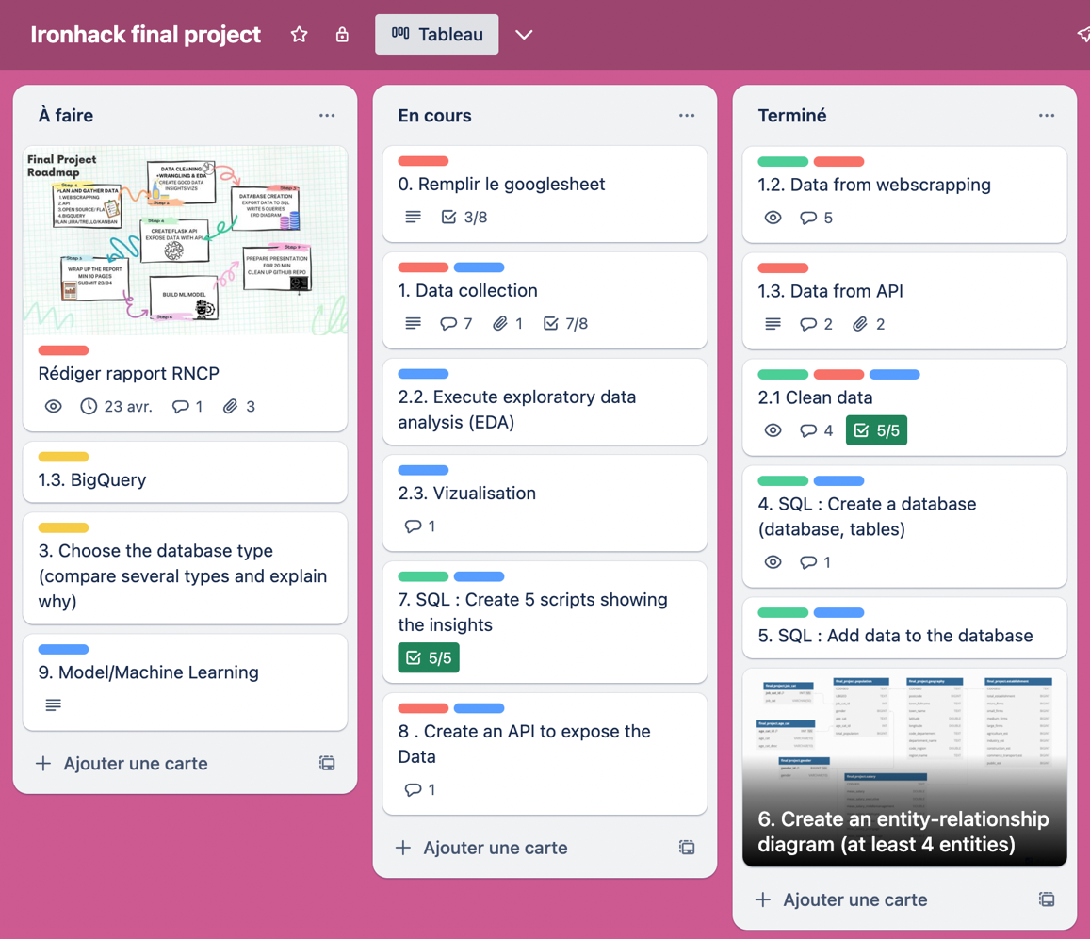

# Data sources & Data collection

## Data from flat files

We sourced our dataset from reliable sources, including the National Institute of Statistics and Economic Studies (INSEE) and the data.gouv.fr platform.

Here's a summary of our data collection:

1. **Number of active establishments as of the end of 2020 grouped into 5 major sectors** :
   * This dataset provides information on the number of active establishments categorized into five major sectors. It offers insights into the distribution of establishments across different sectors at the end of the year 2020.
   * <https://www.insee.fr/fr/statistiques/4991205>
   * ‘etablissement.csv’
   * Shape = Rows : 34 980 - Columns : 61
2. **Average net hourly wage by socio-professional category, gender, and age in 2020** :
   * This dataset offers details on the average net hourly wage based on socio-professional category, gender, and age in the year 2020. It enables analysis of wage disparities across various socio-demographic groups.
   * <https://www.insee.fr/fr/statistiques/2021266>
   * ‘salaire_par_commune.csv’
   * Shape = Rows : 5 421 - Columns : 25
3. **Population aged 15 years and older by gender, age, and socio-professional category** :
   * This dataset presents demographic information on the population aged 15 years and older, segmented by gender, age, and socio-professional category. It allows for a comprehensive examination of the demographic composition and socio-economic characteristics of the population.
   * <https://www.insee.fr/fr/statistiques/7631680?sommaire=7632456>
   * ‘population.csv’

* Shape = Rows : 1 738 965 - Columns : 7

1. **Communes de France - Base of postal codes** :
   * This dataset, provided by La Poste, includes the names of regions, departments, and municipalities in lowercase letters, along with their respective INSEE codes. It serves as a valuable resource for geographic analysis and mapping.
   * <https://www.data.gouv.fr/fr/datasets/communes-de-france-base-des-codes-postaux/>
   * ‘communes-departement-region.csv’
   * Rows : 5 421 - Columns : 15

We specifically chose data from the year 2020 to maintain consistency throughout our dataset, as certain data for subsequent years was not available. This decision ensures coherence, reliability and completeness in our analysis and allows for meaningful comparisons across different variables and indicators.

## Data from API

The data collection process also involved extracting relevant information from the United Nations Statistics Division SDG API, specifically focusing on target ‘5.5’, which pertains to ensuring women's full and effective participation and equal opportunities for leadership at all levels of decision-making, and on the area code ‘250’ for France.

This API enables an access to data related to the proportion of women holding managerial positions in France. By leveraging this API, we can retrieve valuable insights into the representation of women in leadership roles. This dataset from the SDG API complements our other sources of data and contributes to a more comprehensive analysis of gender equality and women's empowerment in France.

* SDG API link : <https://unstats.un.org/sdgapi/swagger/#!/Target/V1SdgTargetDataGet>
* Target for the API : <https://sdgs.un.org/goals/goal5#targets_and_indicators>
* Data from API : ‘api_data5.5_raw.csv’
* Shape = Rows : 140 - Columns : 21

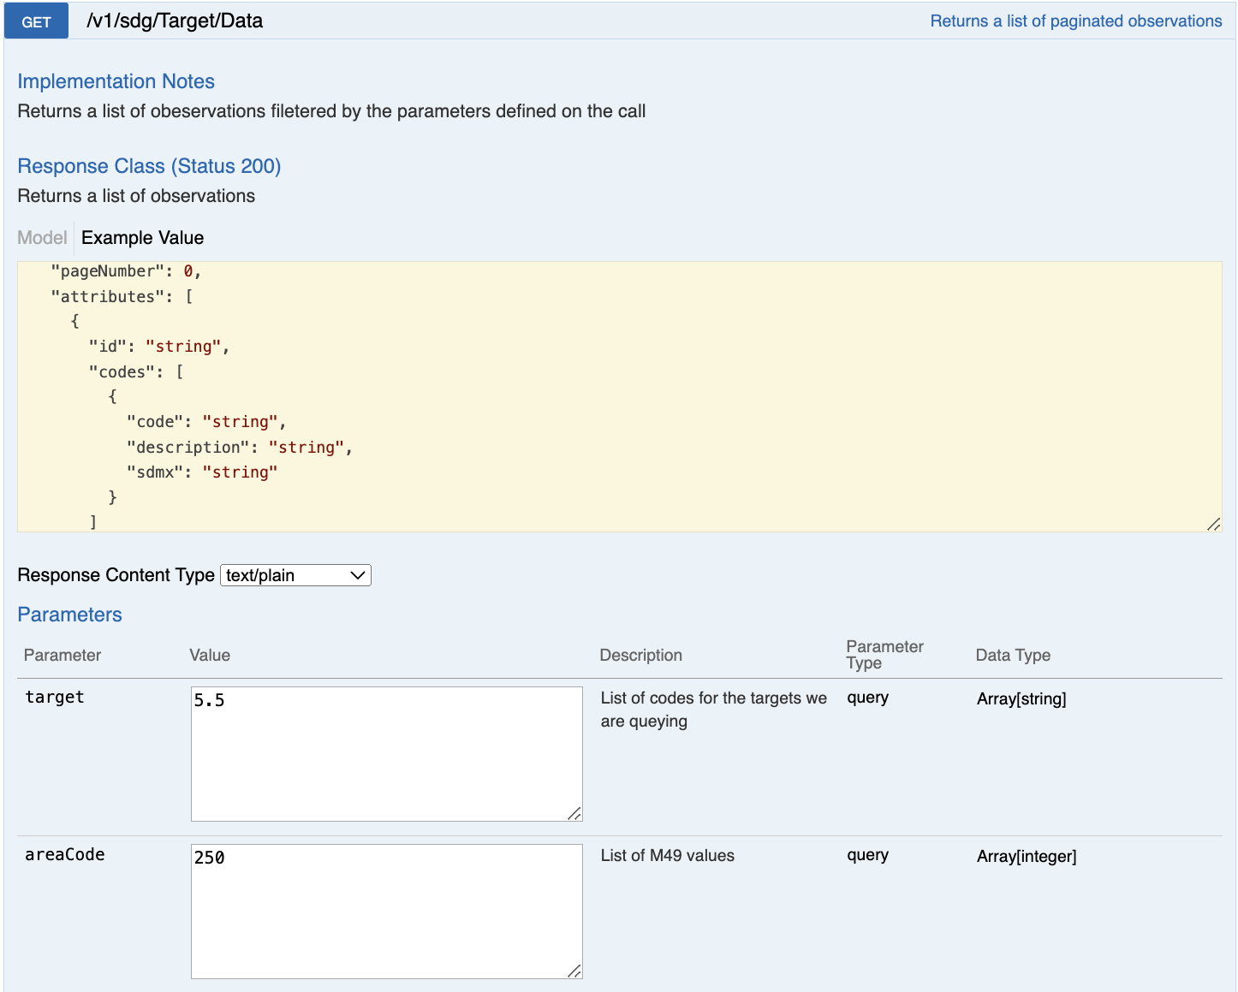

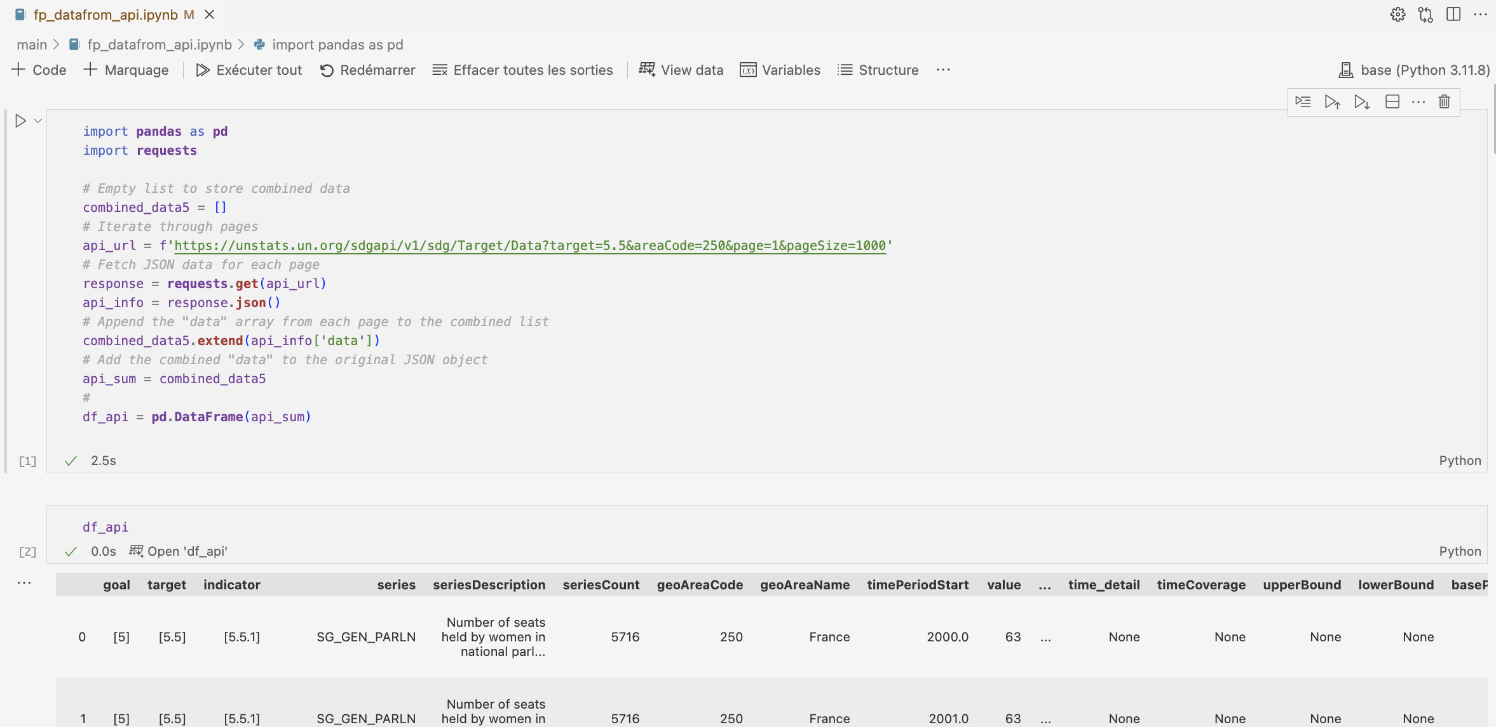

## Data from web scraping

For the collection of data on professions and socio-professional categories (PCS), we utilized web scraping techniques to extract information from the Wikipedia page titled "Professions et catégories socioprofessionnelles en France." Specifically, we focused on retrieving data from the third table on the page, which provides the correspondence between socio-professional categories and socio-professional groups.

The professions and socio-professional categories (PCS) serve as a statistical classification system used to categorize occupations. This classification was established by the National Institute of Statistics and Economic Studies (INSEE) in 1982. By scraping this data from Wikipedia, we were able to obtain more insights into the classification of professions and socio-professional categories, which are essential for our analysis of various socio-economic factors in France.

* URL: <https://fr.wikipedia.org/wiki/Professions_et_cat%C3%A9gories_socioprofessionnelles_en_France>
* Data from webscraping : ‘cat_job_webscrap_raw.csv’
* Shape = Rows : 42 - Columns : 4

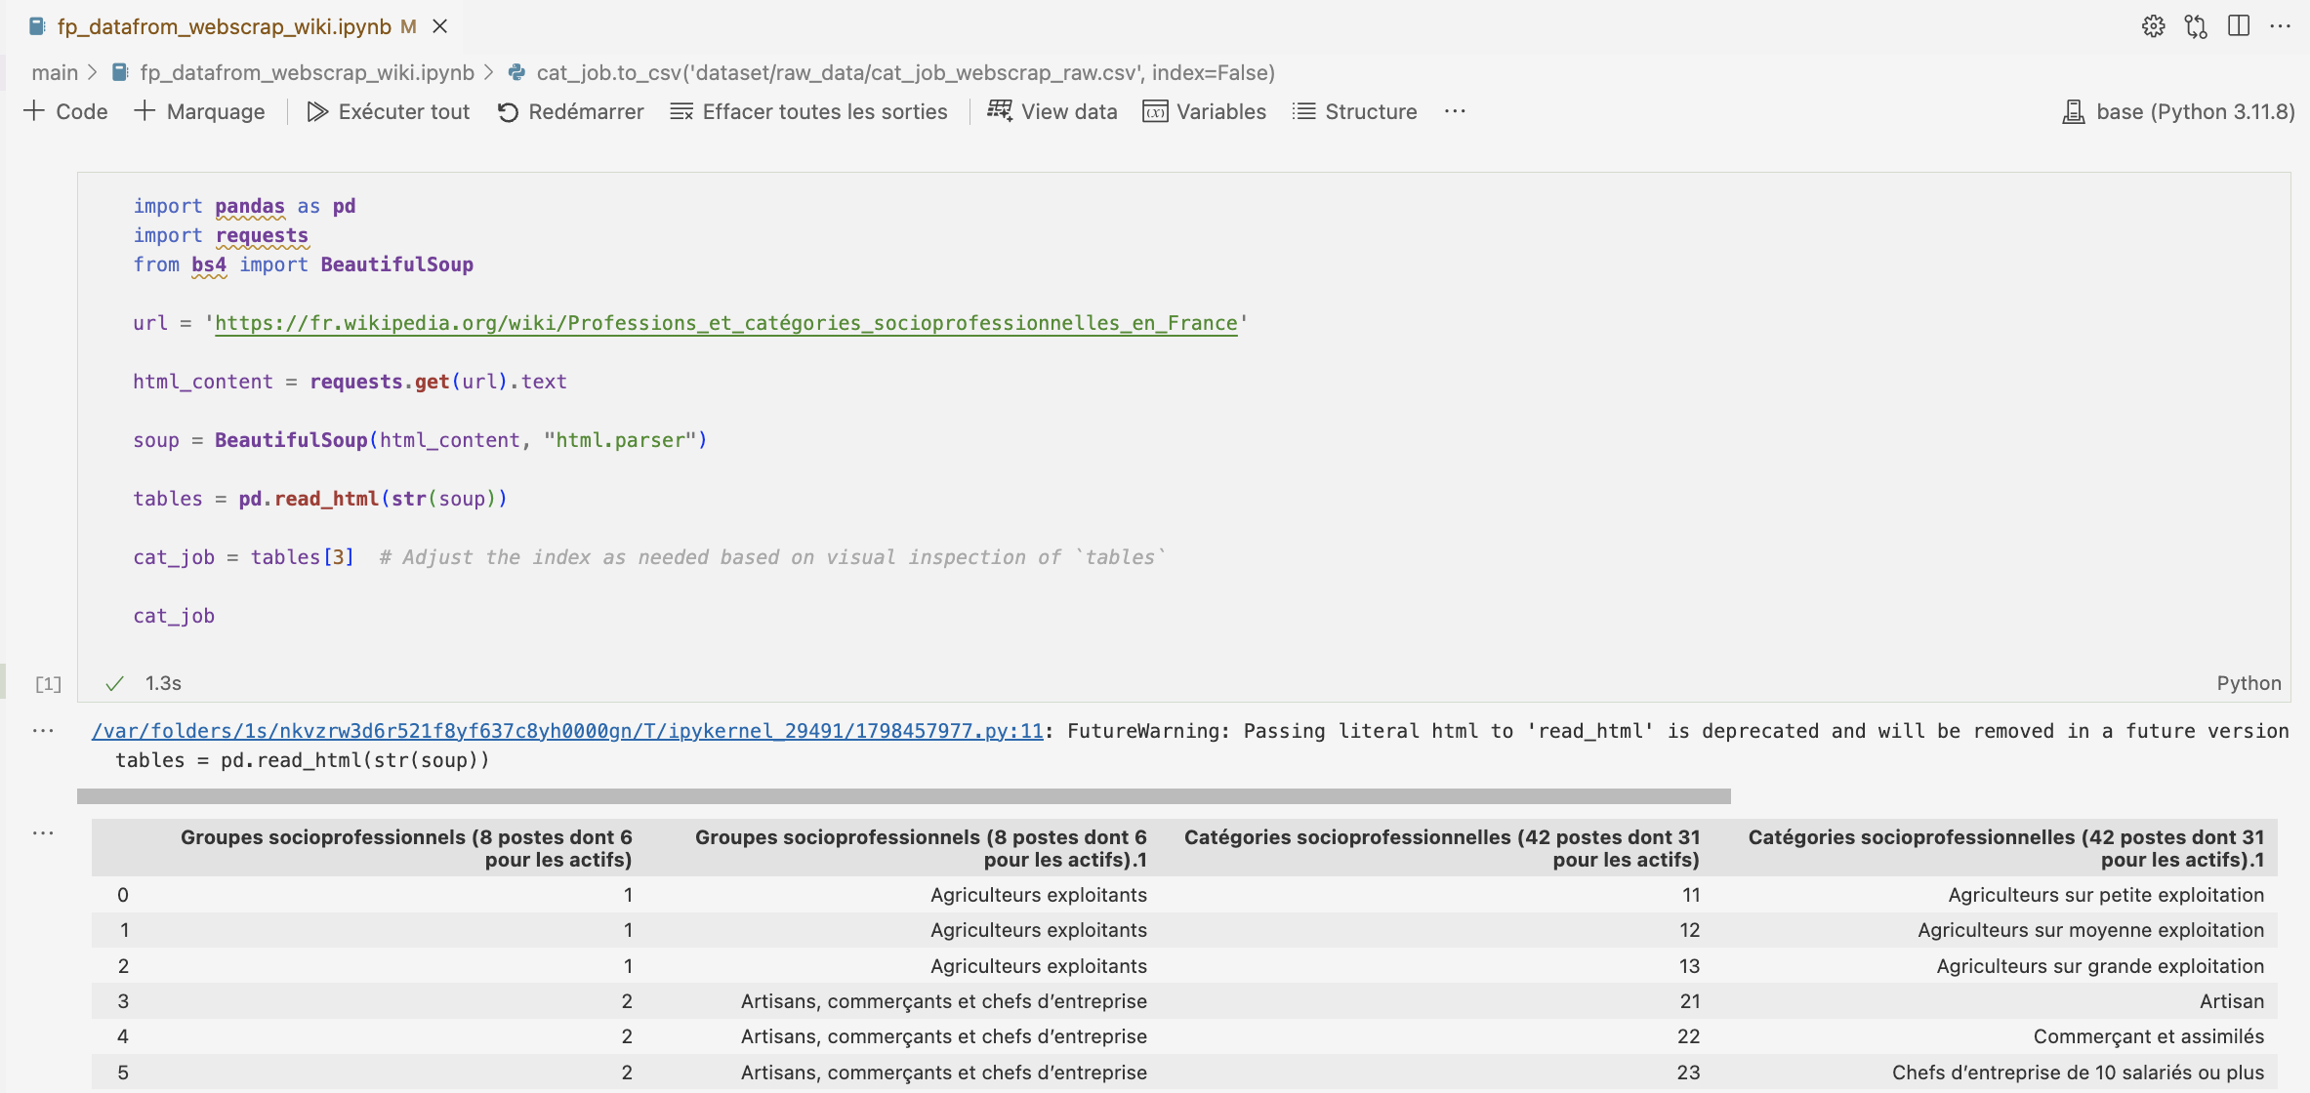

## Data from Big Query

I was unable to locate an appropriate database on BigQuery, I opted to upload a cleaned CSV file to BigQuery for query execution. I uploaded it directly through the console and created a new table :

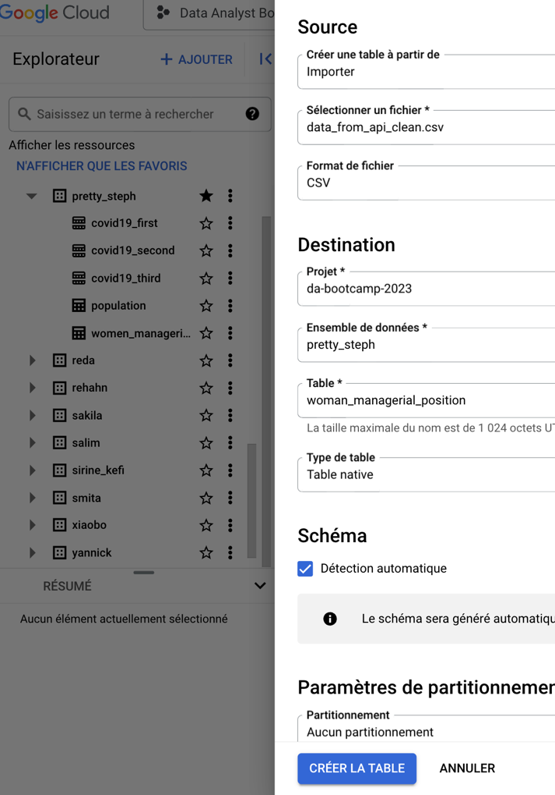

* Information on the schema setup and detailed description of the data structure :

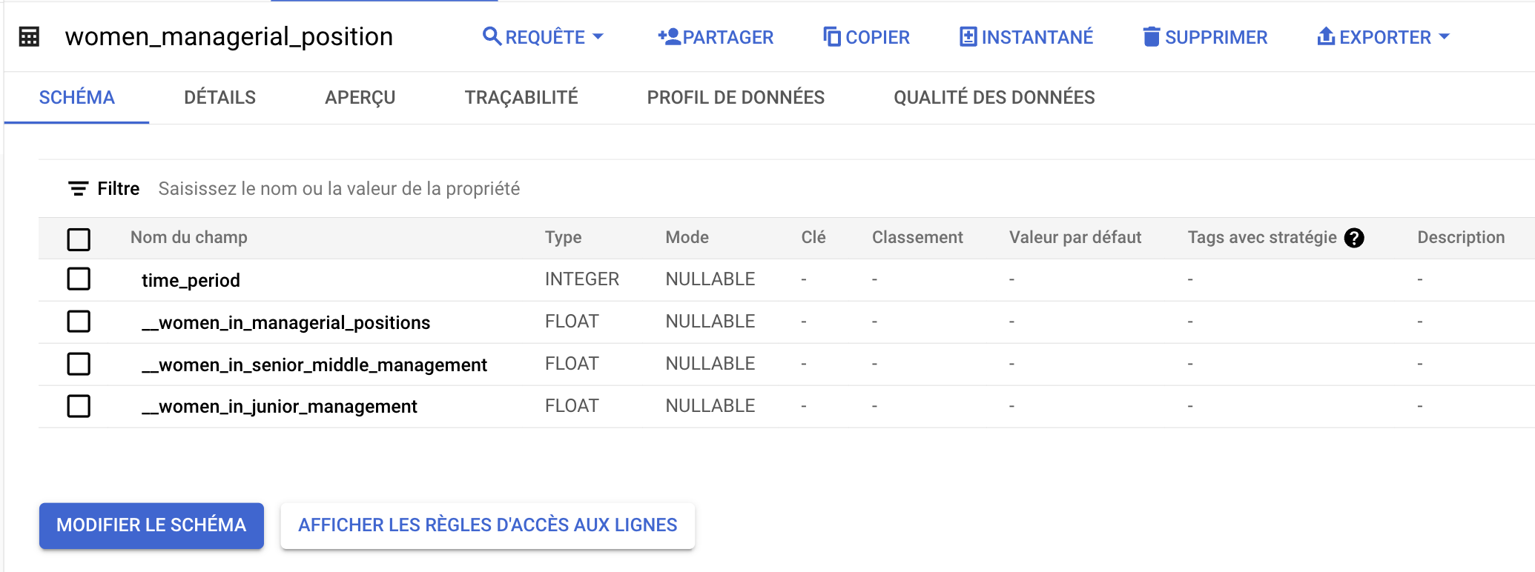

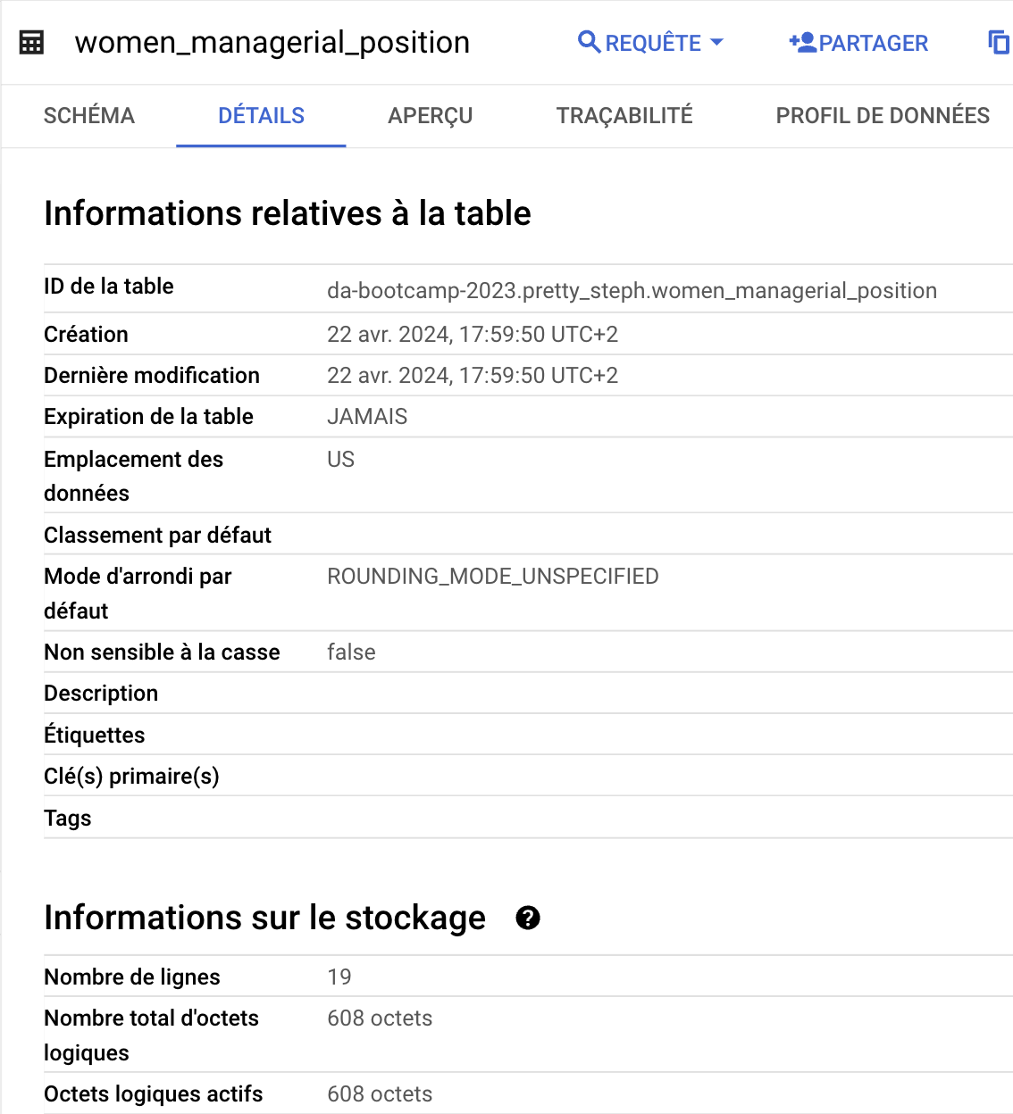

* Examples of queries:

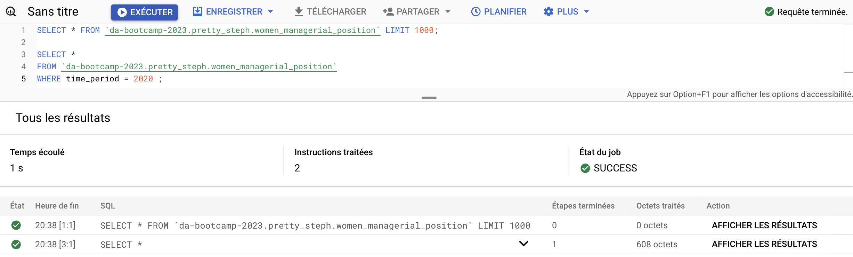

* Results

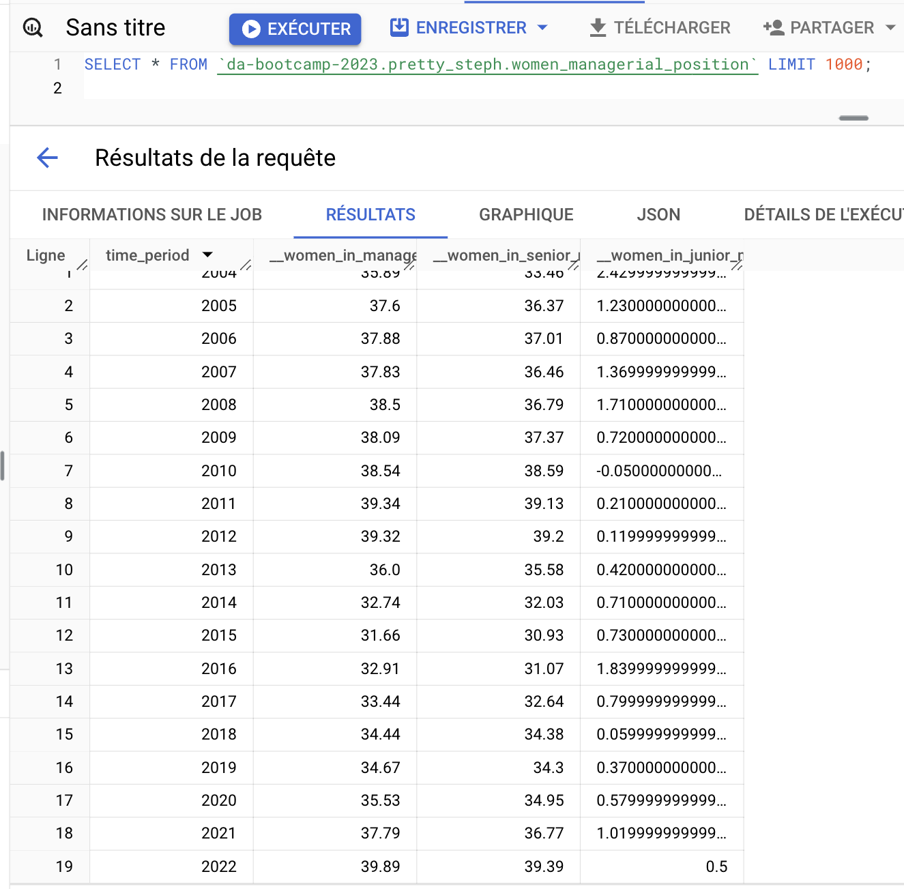

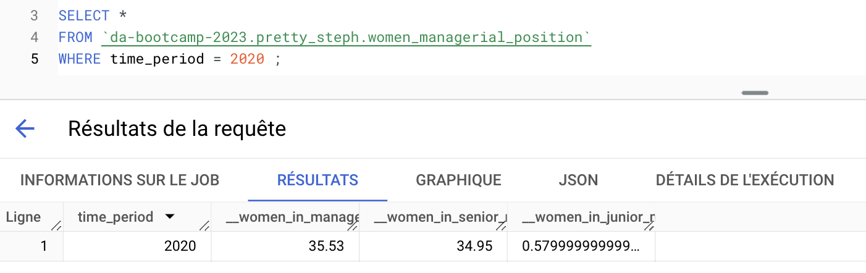

# Data cleaning & Exploratory data analysis

## Data cleaning and wrangling

Once the data collection phase was completed, the subsequent task involved cleaning the

gathered data to construct the database and ensure its readiness for utilization in both the

API and the machine learning model.

Several data cleaning procedures were executed, including ;

* Checking and handling the data types :

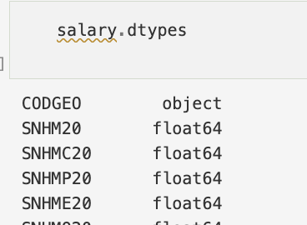



* Handling null values

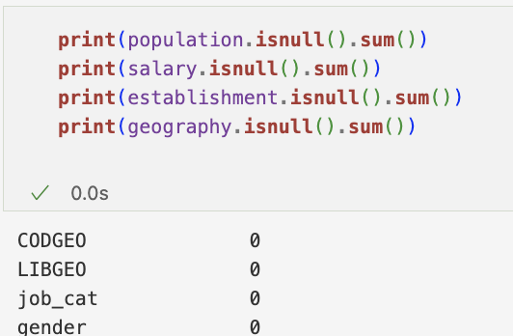 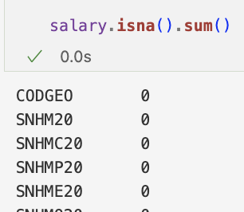

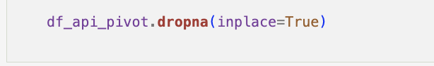

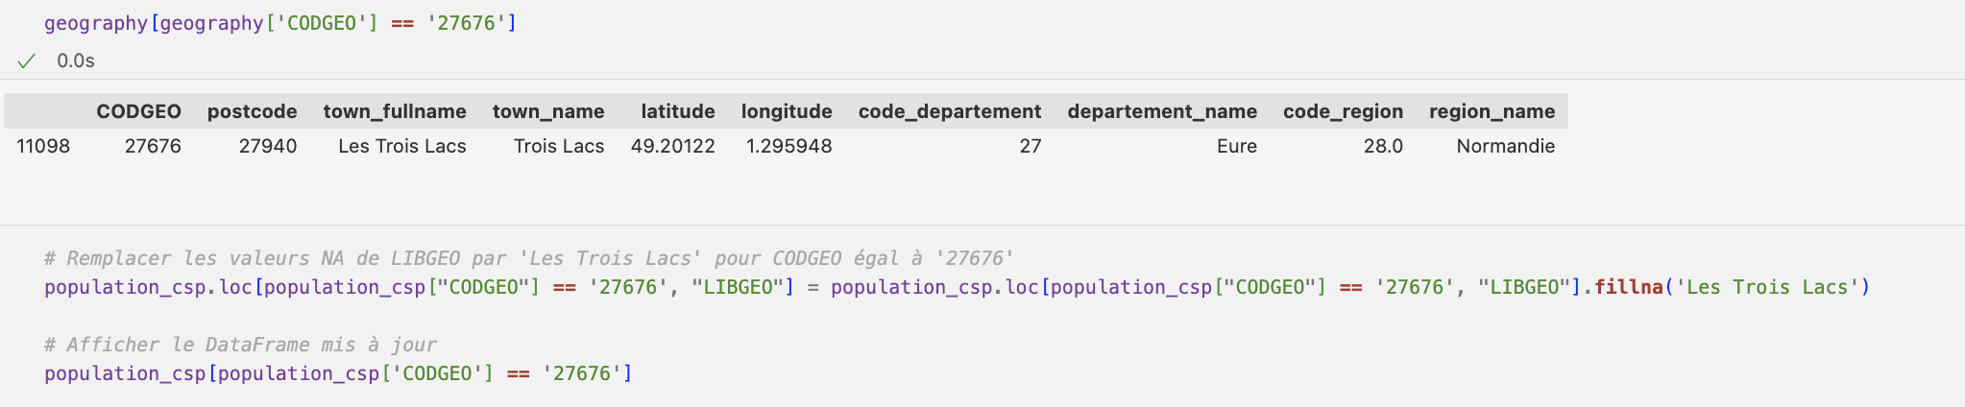

* Checking and handling duplicates

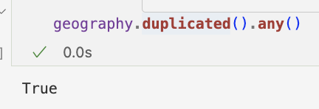 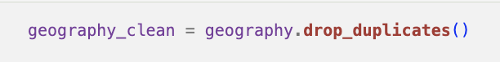

* Checking unique values :

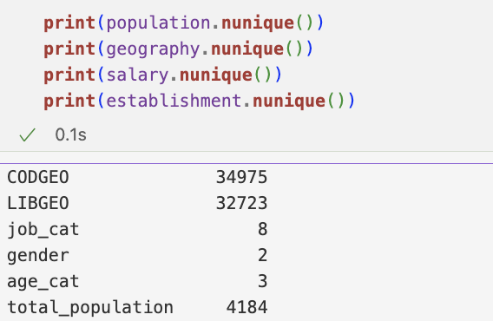

* Cleaning columns names, dropping & reorganizing columns :

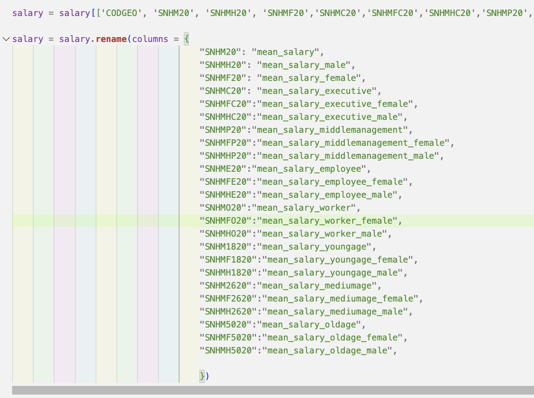

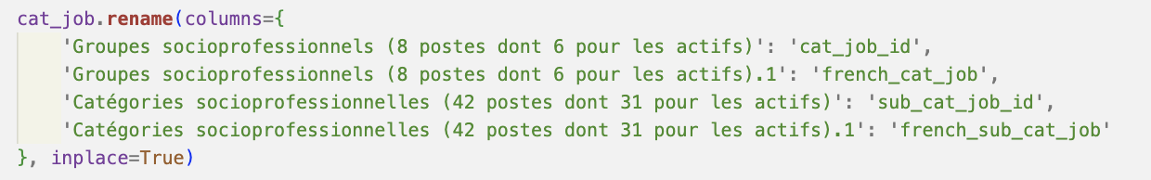

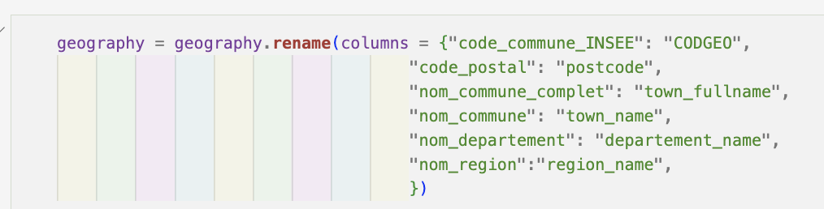

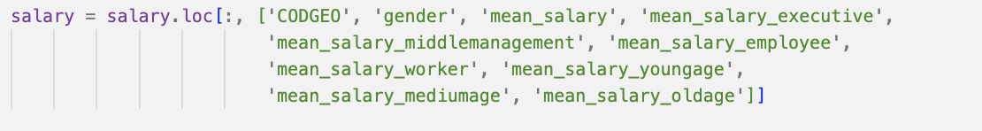



* Value formatting



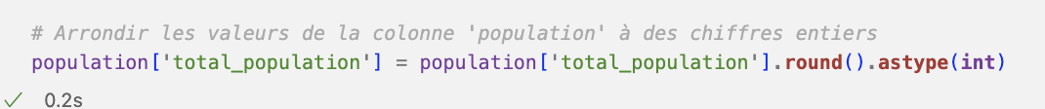

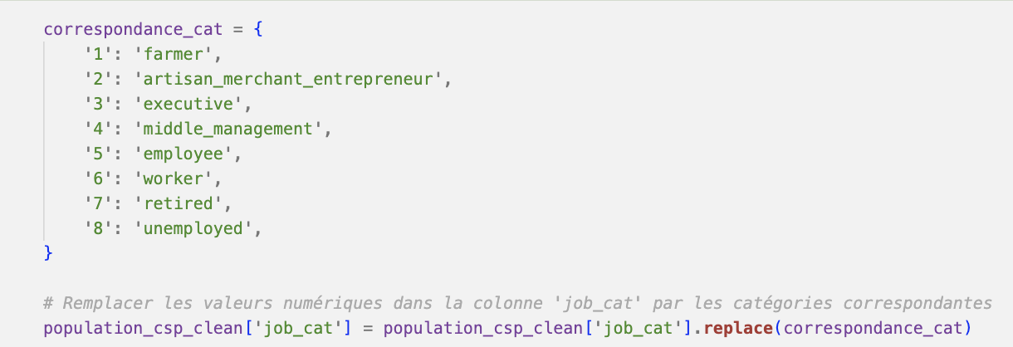

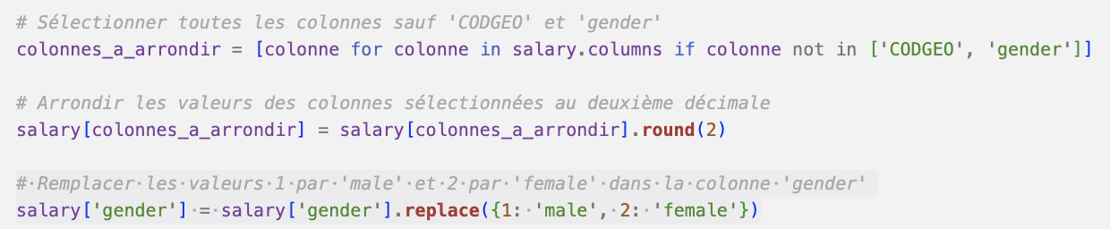

* Reducing the number of categories

By creating larger categories or bins :

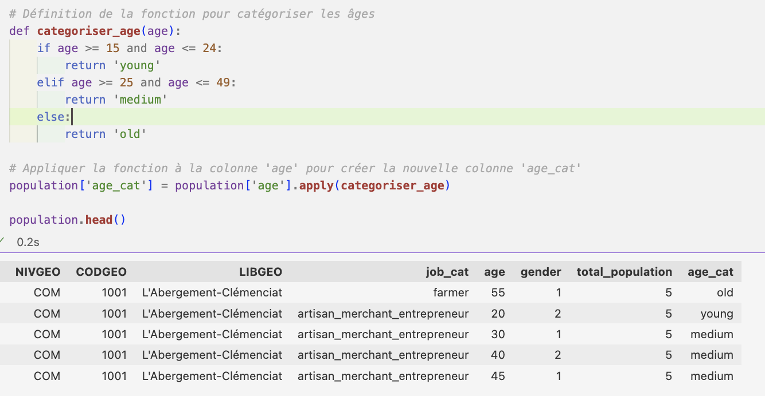

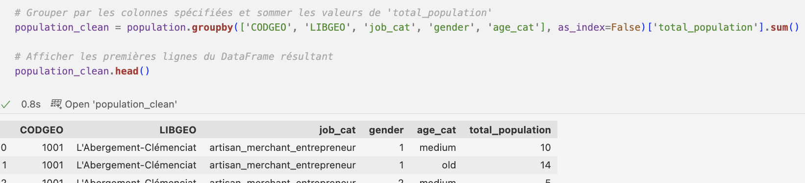

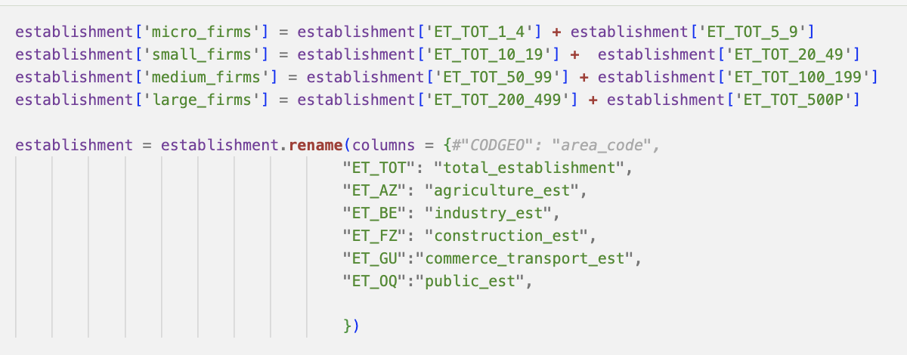

* Data homogenization and normalization

Here, we want to separate salary by gender in 2 data frames, and then concatenate them back together after homogenizing the column names:

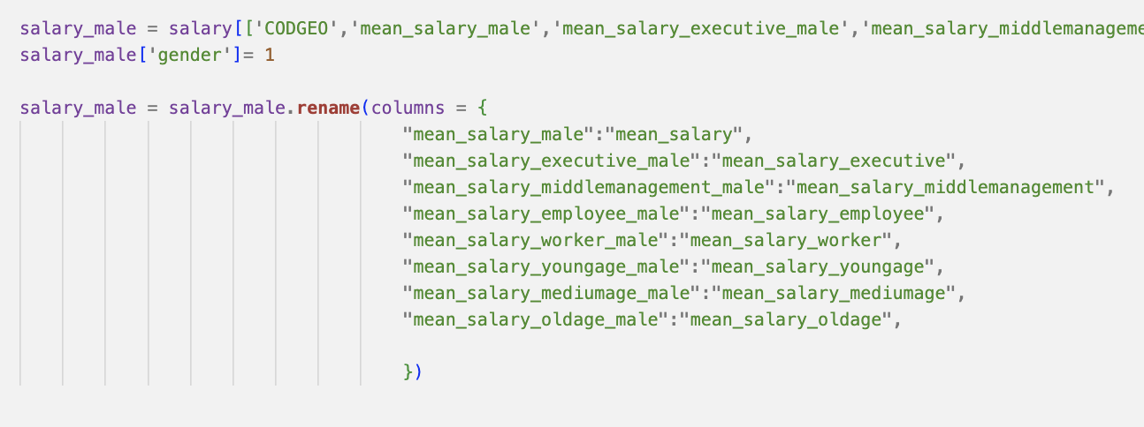

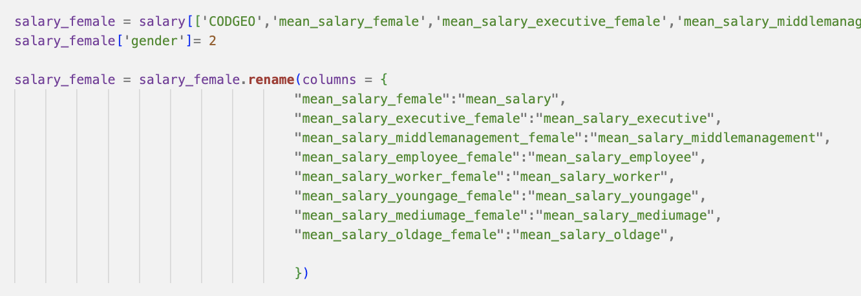

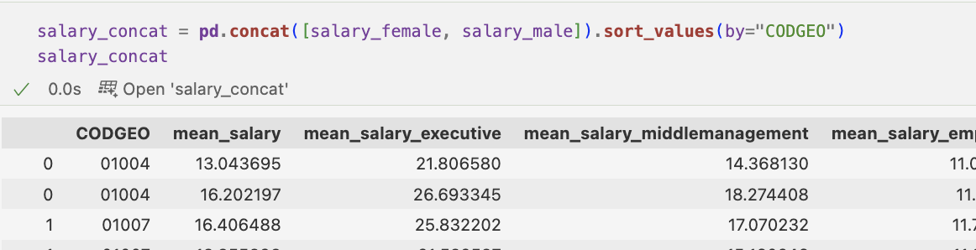

Shape before : Shape after :

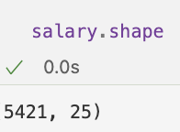 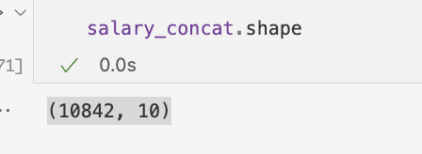

* Filtering on columns, pivot the table, and or adding columns with calculation to get the data and the data frame wanted :

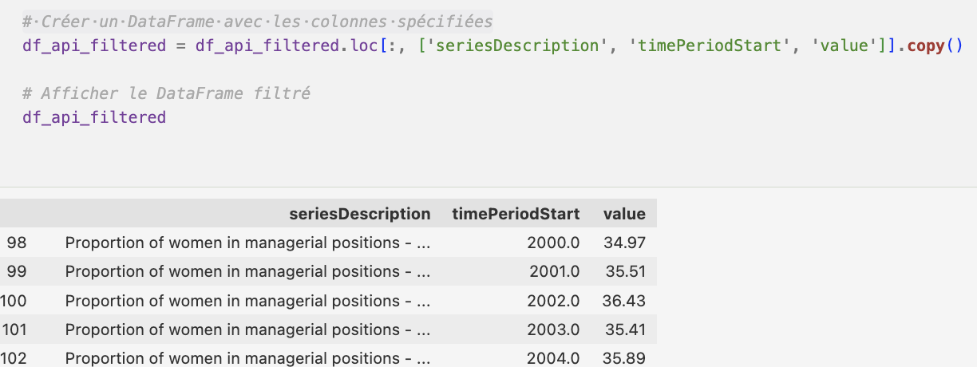

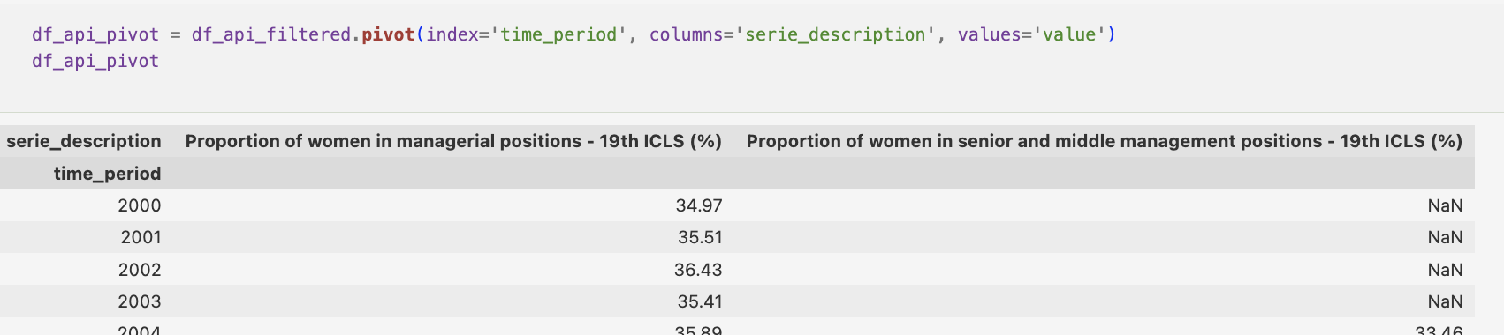

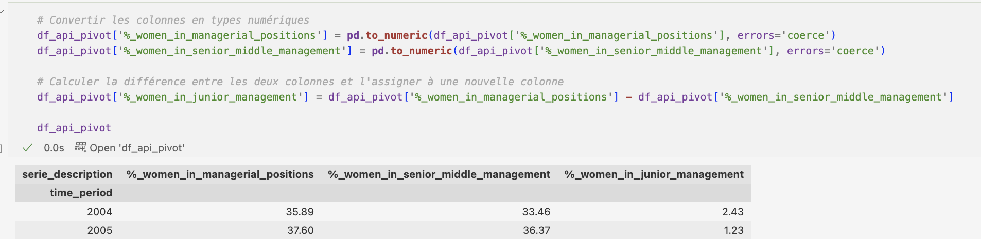

## Cleaned datasets summary

At the end of these processes, our clean datasets are :

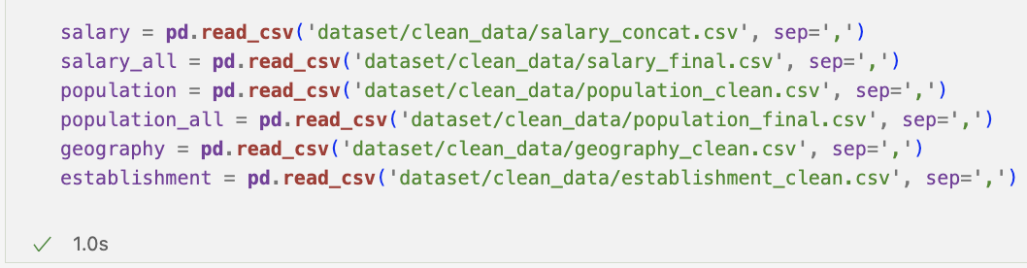

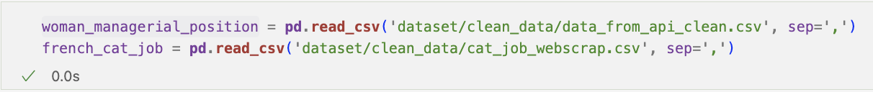

The datasets now consist of the following columns :

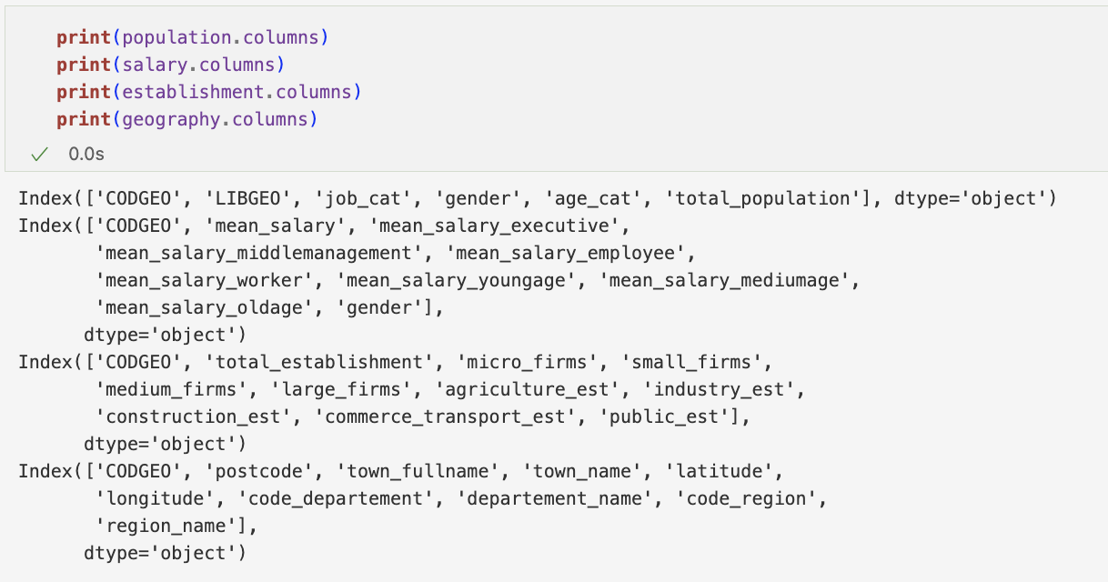

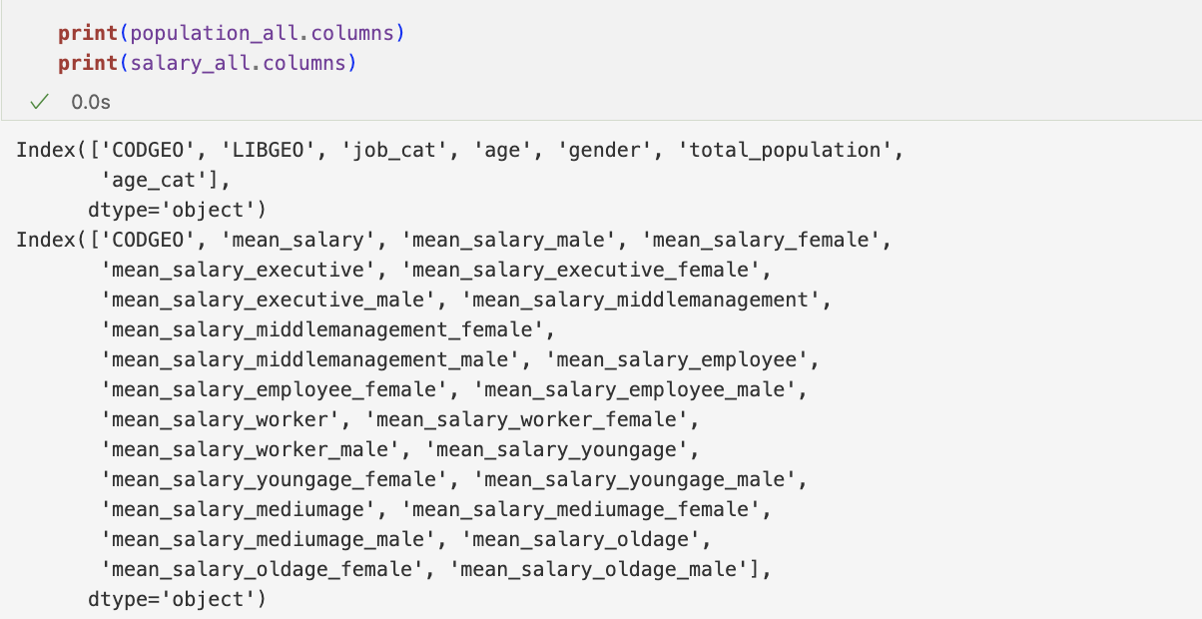

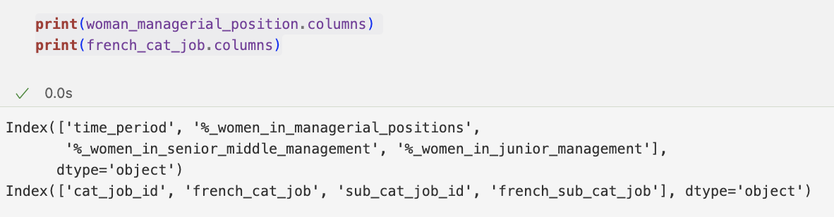

To summarize :

1. **Population Dataset**: population = ‘population_clean.csv’ – Shape : (826 266 x 6)
   * 'CODGEO' represents the geographical code
   * 'LIBGEO' represents the geographical name
   * 'job_cat' represents the job category
   * 'gender' represents the gender
   * 'age_cat' represents the age category
   * 'total_population' represents the total population in each geographical area

* *population_all = ‘population_final.csv’ – Shape : (1 738 965 x 7)*
* *population df before age categorization*
* *includes the additional columns ‘age’ compared to the* ***population*** *dataset representing the age of the population by bins of 5 year*

1. **Salary Dataset** : salary = ‘salary_concat.csv’ – Shape : (10 842 x 10)
   * 'CODGEO' represents the geographical code
   * 'mean_salary' represents the mean salary
   * Columns like 'mean_salary_executive', 'mean_salary_middlemanagement', etc., represent the mean salary for different job categories
   * 'gender' represents the gender

* *salary_all = ‘salary_final.csv’ – Shape : (5 421 x 25)*
  + *salary df before normalization*
  + *includes several additional columns compared to the* ***salary*** *dataset, which provide more detailed information about salaries based on gender and job category.*

1. **Establishment Dataset** : establishment = ‘establishment_clean.csv’ – Shape : (34 980 x 11)
   * 'CODGEO' represents the geographical code
   * 'total_establishment' represents the total number of establishments
   * Other columns represent the number of establishments based on their size and sector
2. **Geography Dataset** : geography = ‘geography_clean.csv’ – Shape : (36 370 x 10)
   * 'CODGEO' represents the geographical code.
   * 'postcode' represents the postal code
   * 'town_fullname' and 'town_name' represent the name of the town.
   * 'latitude' and 'longitude' represent the geographical coordinates
   * 'code_departement', 'departement_name', 'code_region', and 'region_name' represent the administrative divisions
3. **Proportion of women in managerial positions Dataset :** 
   * woman_managerial_position=‘data_from_api_clean.csv’ – Shape : (19 x 4)
   * time_period: Time period for the data
   * %_women_in_managerial_positions: Percentage of women in managerial positions
   * %_women_in_senior_middle_management: Percentage of women in senior middle management positions
   * %_women_in_junior_management: Percentage of women in junior management positions
4. **French job classification and socio-professional categories Dataset :** 
   * french_cat_job **=** ‘cat_job_webscrap.csv’ – Shape : (42 x 4)
   * cat_job_id: Identifier for the job category
   * french_cat_job: Main job category in French
   * sub_cat_job_id: Identifier for the sub-category job
   * french_sub_cat_job: Sub-category job within the main job category in French

## **Exploratory data analysis & Visualization**

### EDA

* Checking number of observations

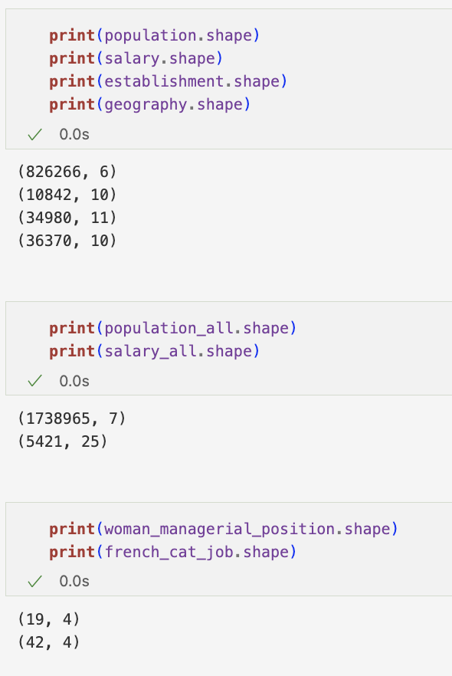

* Checking info of the data frames :

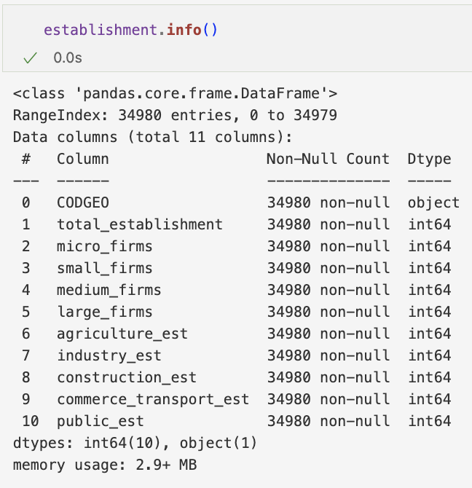

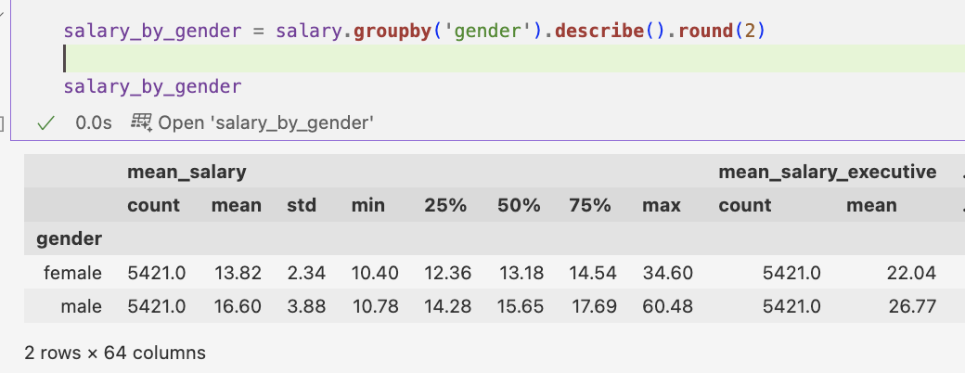

* Descriptive statistics :

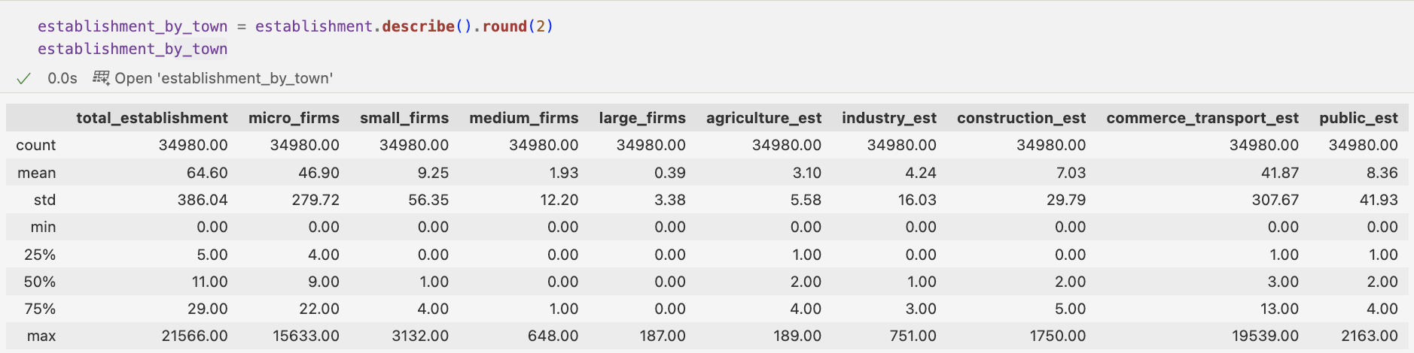

### Visualization

* Population & Establishment demographics :

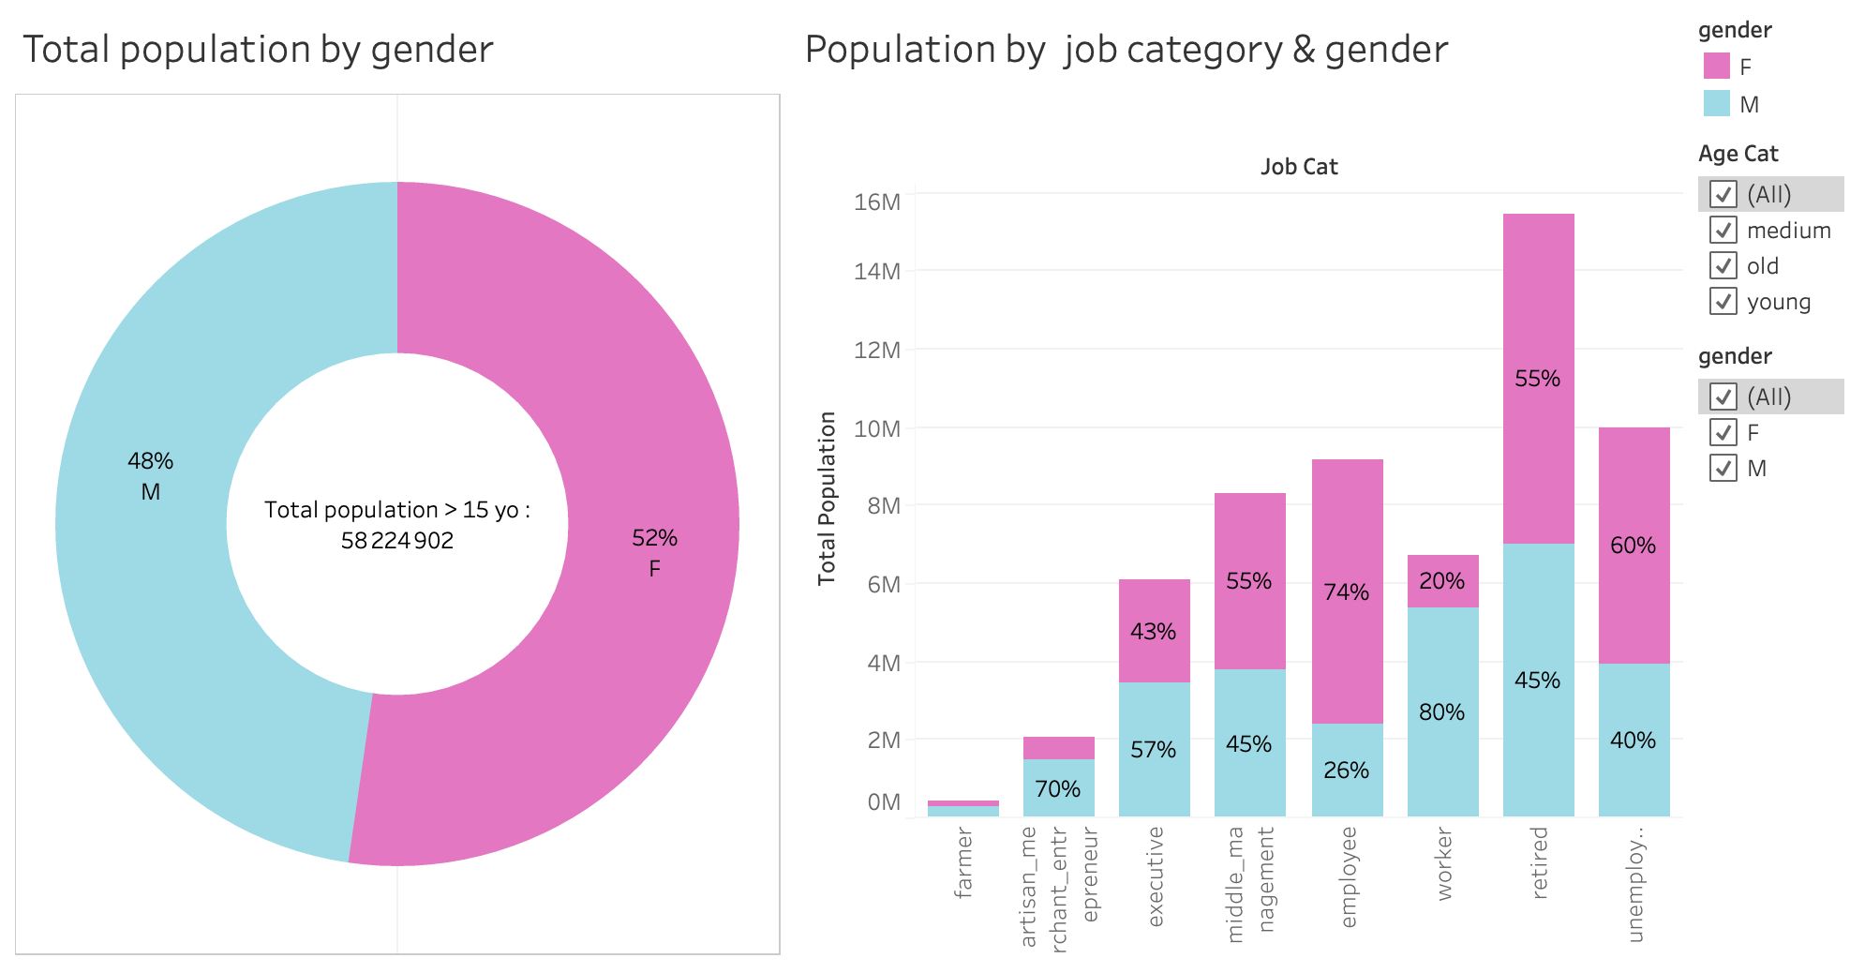

We used two different measures jointly for the proportion of females in the total number of persons employed in managerial positions : the share of females in (total) management and the share of females in senior and middle management (thus excluding junior management). The joint calculation of these two measures provides information on whether women are more represented in junior management than in senior and middle management, thus pointing to an eventual ceiling for women to access higher-level management positions.

From our datasets, we can see that executive males (57%) are represented more than executive females (43%), even though we can see that there is more mid-manager female (55%) than mid-manager males (45%).

We can look at our proportion of women in managerial positions Dataset to see the evolution through years :

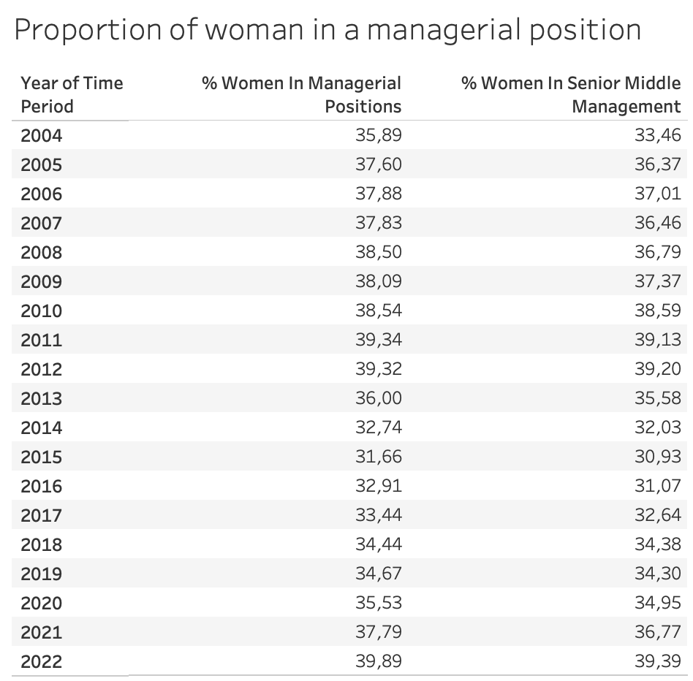

* Age distribution :

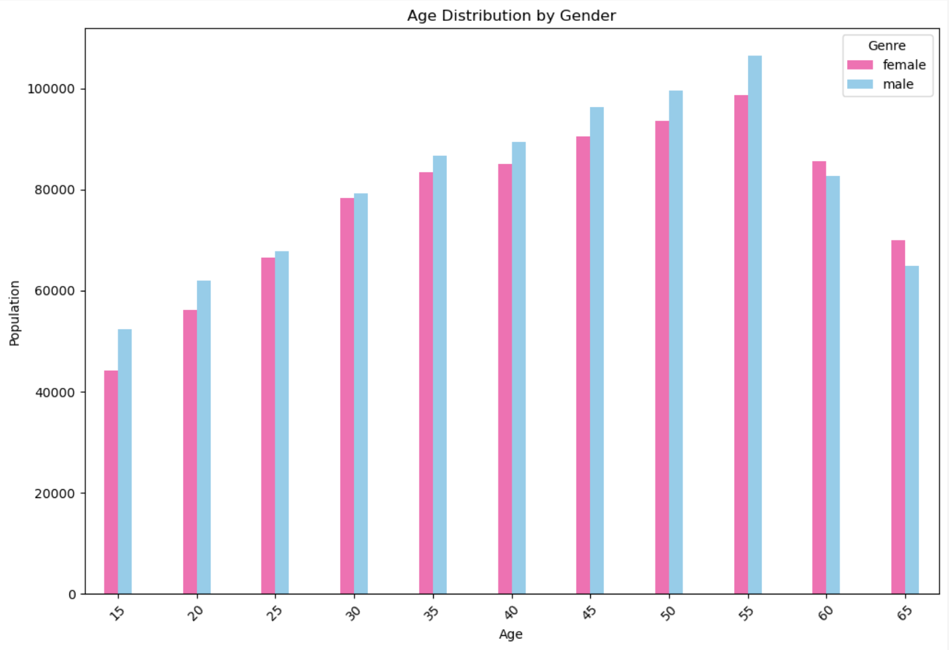

* Population & Establishment correlation :

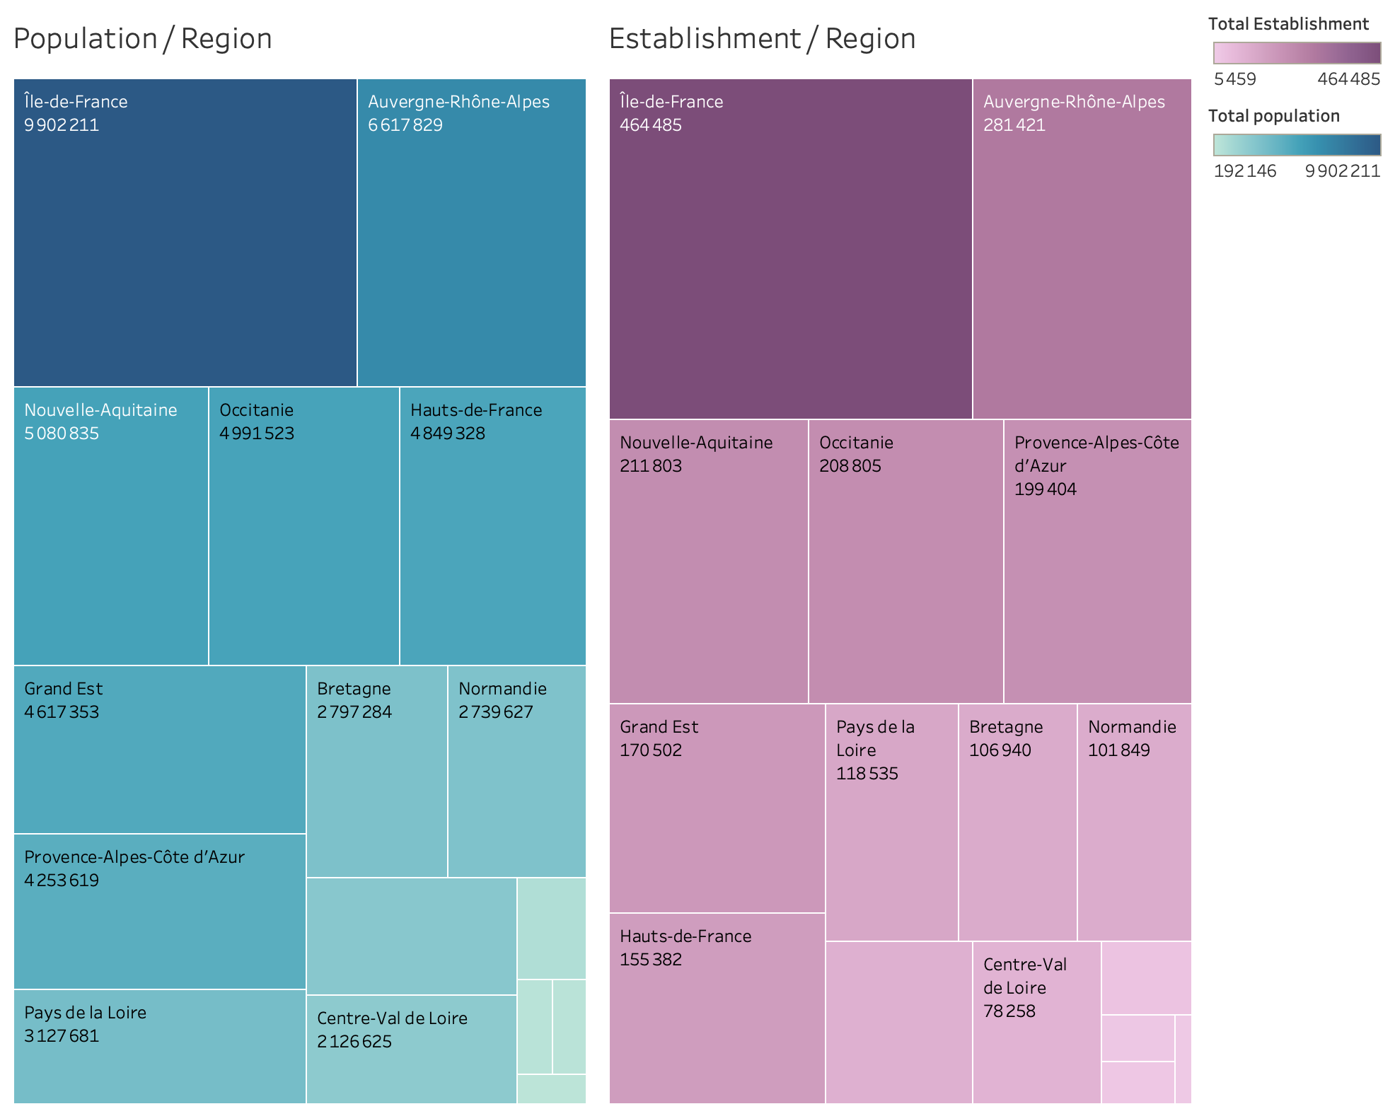

We can see that the most populated regions are also where there is the most establishment.

The Pearson Correlation calculated is 0.6 between those two.

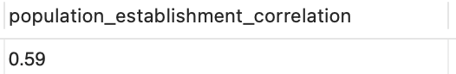

* Distribution of total number of establishments in town :

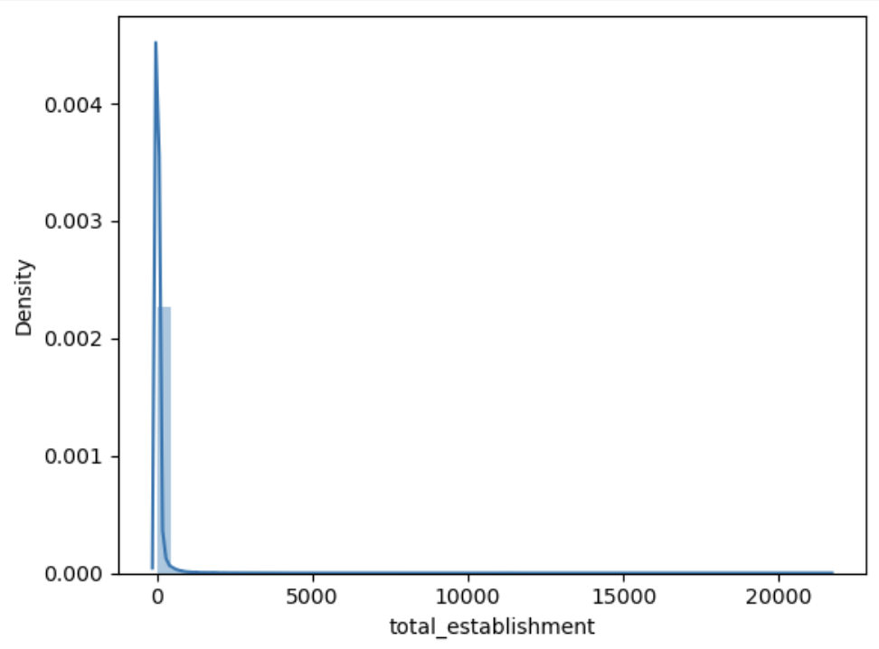

We can find that most of firms are not in a very big scale, so we need to focus on the establishments with relative low number.

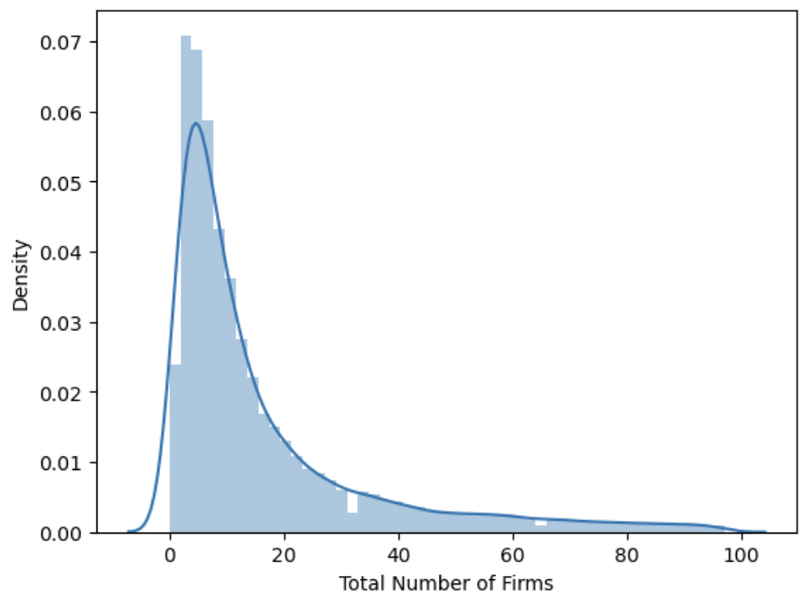

Most of firms' scale are 'Small' and 'Medium'.

Here is the distribution of establishment by size fort the top 5 departments with the most total establishments :

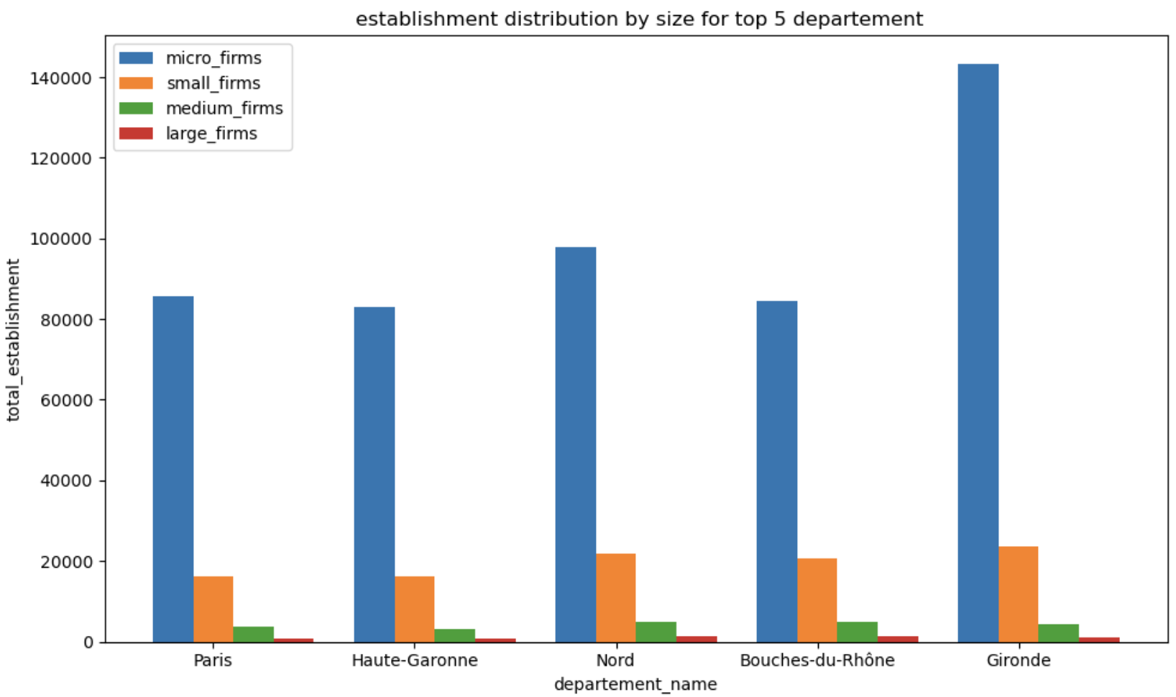

* Salary demographics :

The gender inequalities are even higher in terms of salaries in the managerial positions, and the same goes with the age. The older the population is, the greater is the pay gap between male and female.

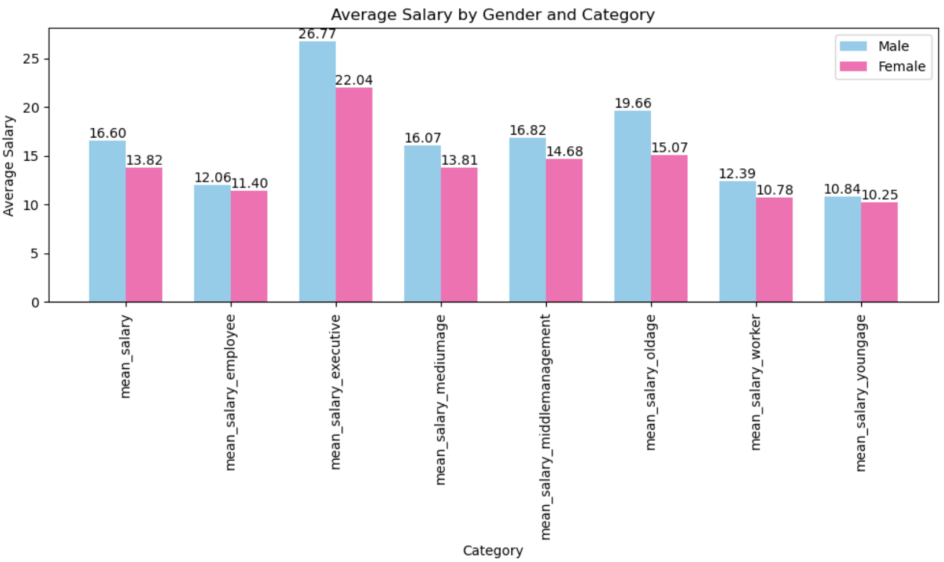

Regions most populated have a higher salary, but also a higher gender pay gap :

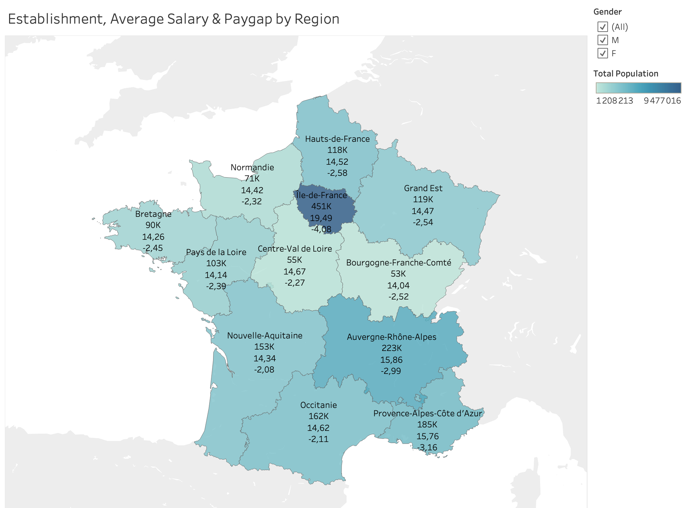

Here is a focus on Ile-de-France :

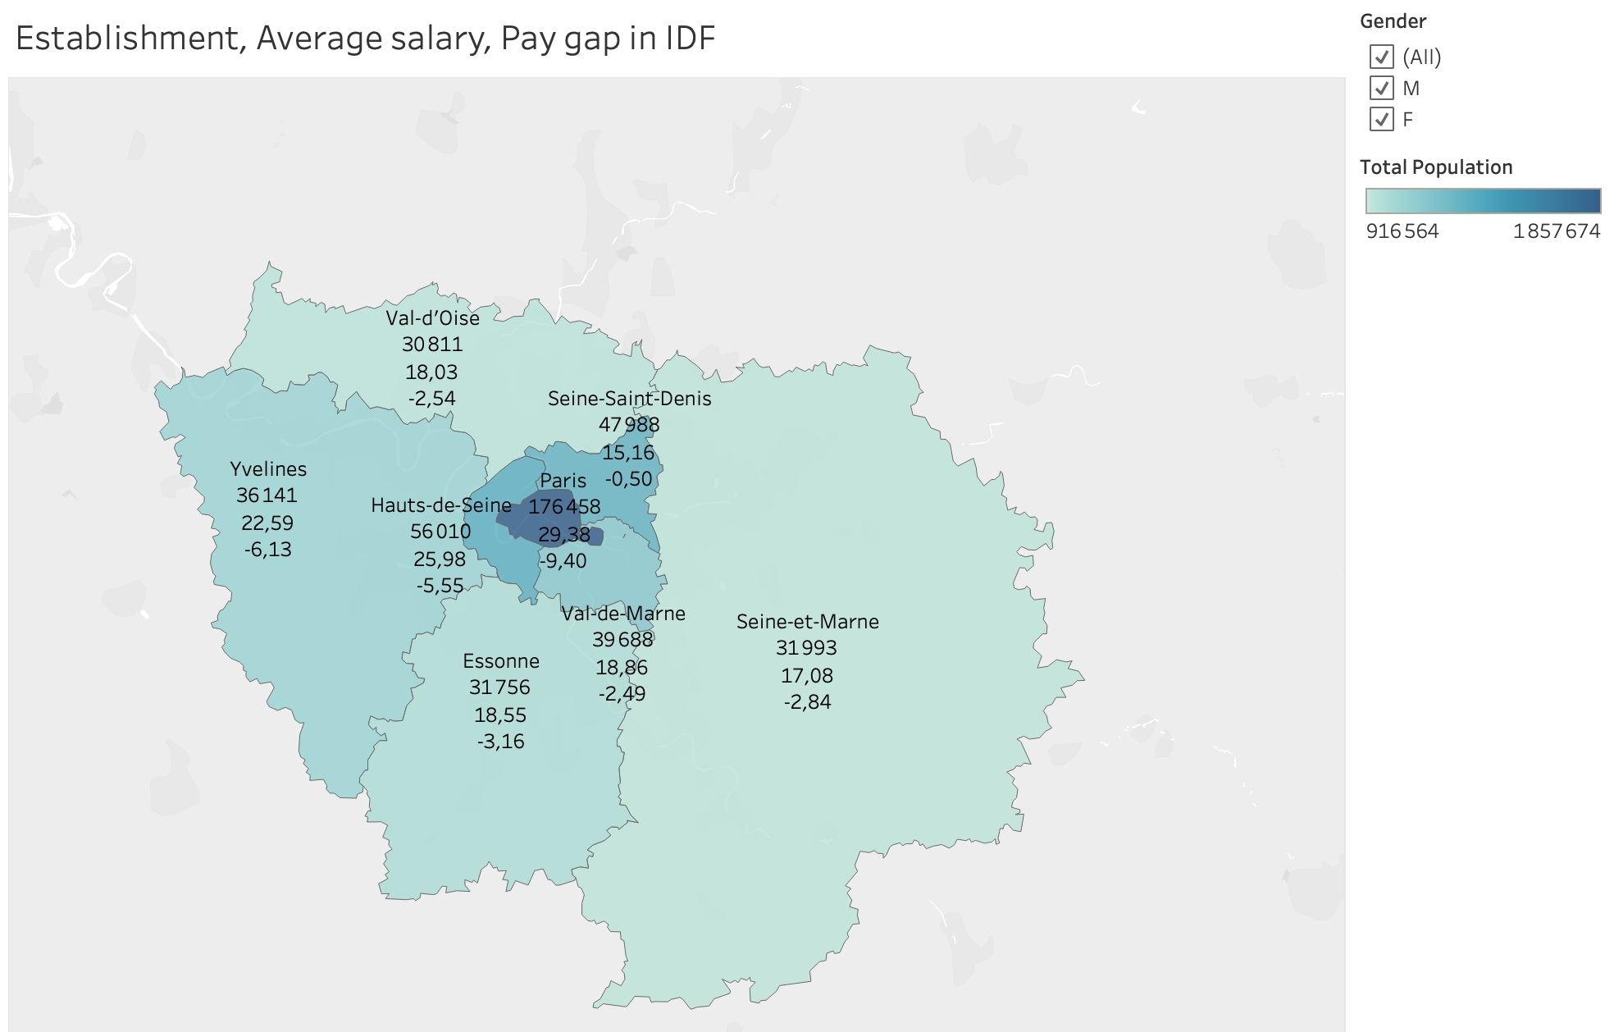

To examine the correlations between our several features (gender, establishment size, population, salaries and job categories, we did a heatmap :

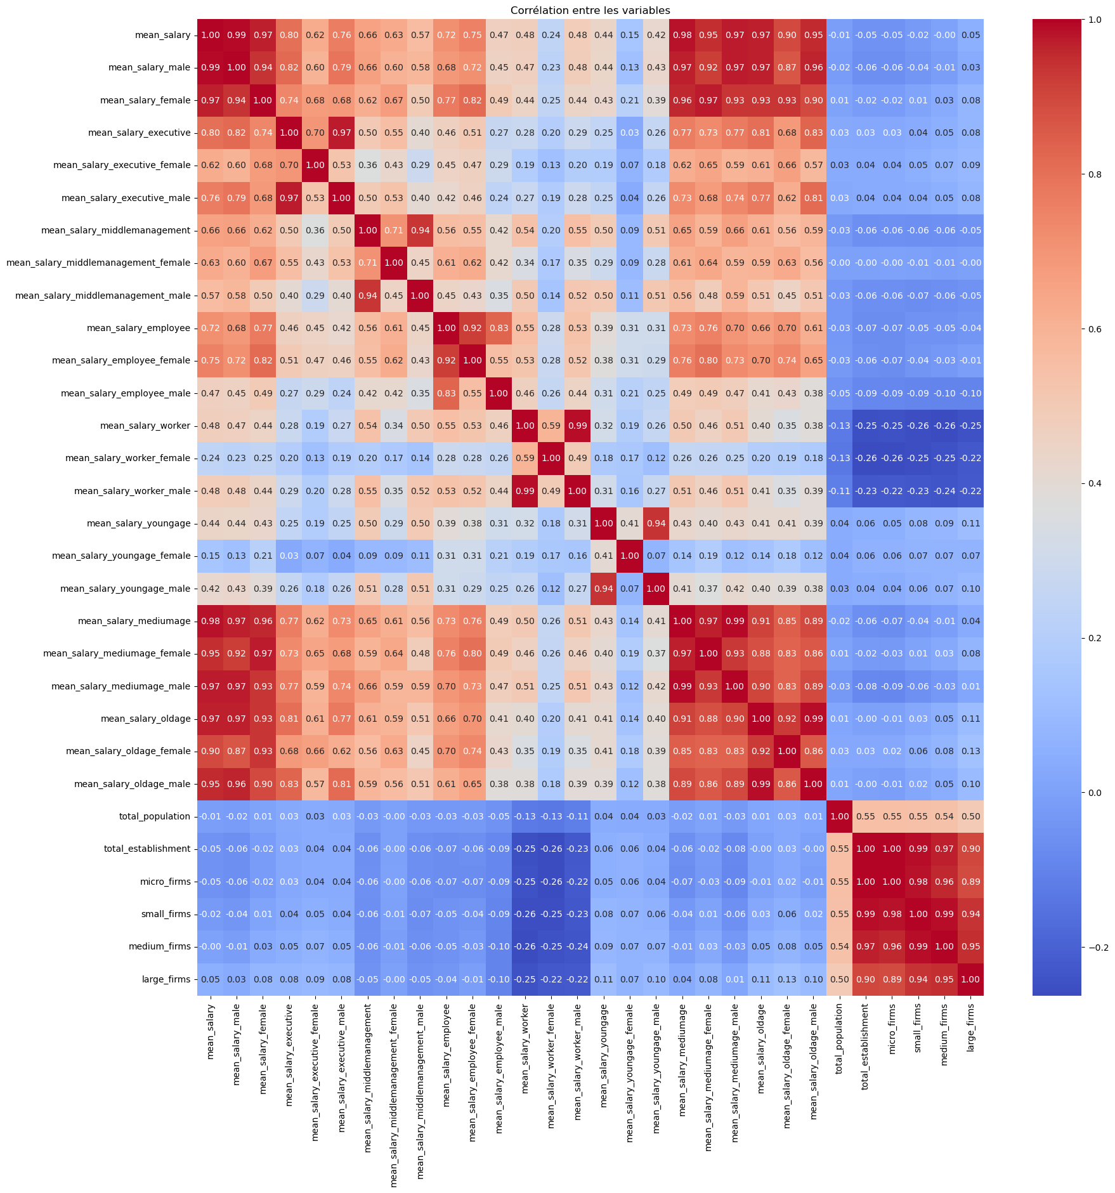

We can see that population is correlated with the firm size and salaries are correlated with gender and job categories. But salaries are not correlated to firm sizes nor population.

# Database, ERD, SQL

## Database

### Type of selection

When it comes to the choice of a database type, since we have structured data organized into interrelated tables with a predefined schema, relationships, and foreign keys it seemed appropriate to use a Relational Database. This type of database will help to reduce data redundancy and improve data integrity, easily manipulate data, and then, use SQL to perform queries that involve joining data from multiple tables.

### Database creation

The ‘final_project’ database was created in MySQL Workbench to store 7 tables related to our subject which we collected through flat files, API and web scraping, and 3 tables that we have normalized from our datasets.

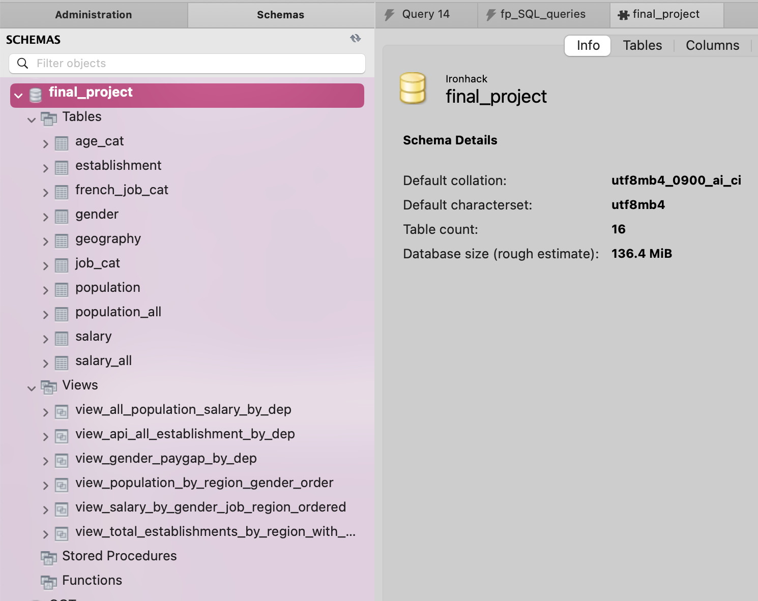

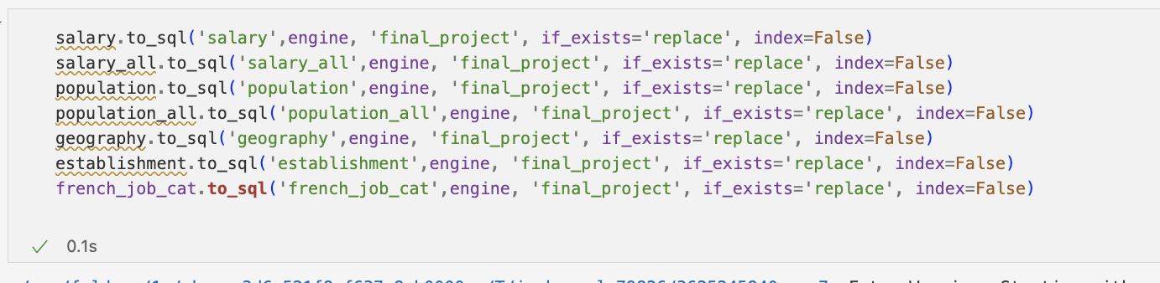

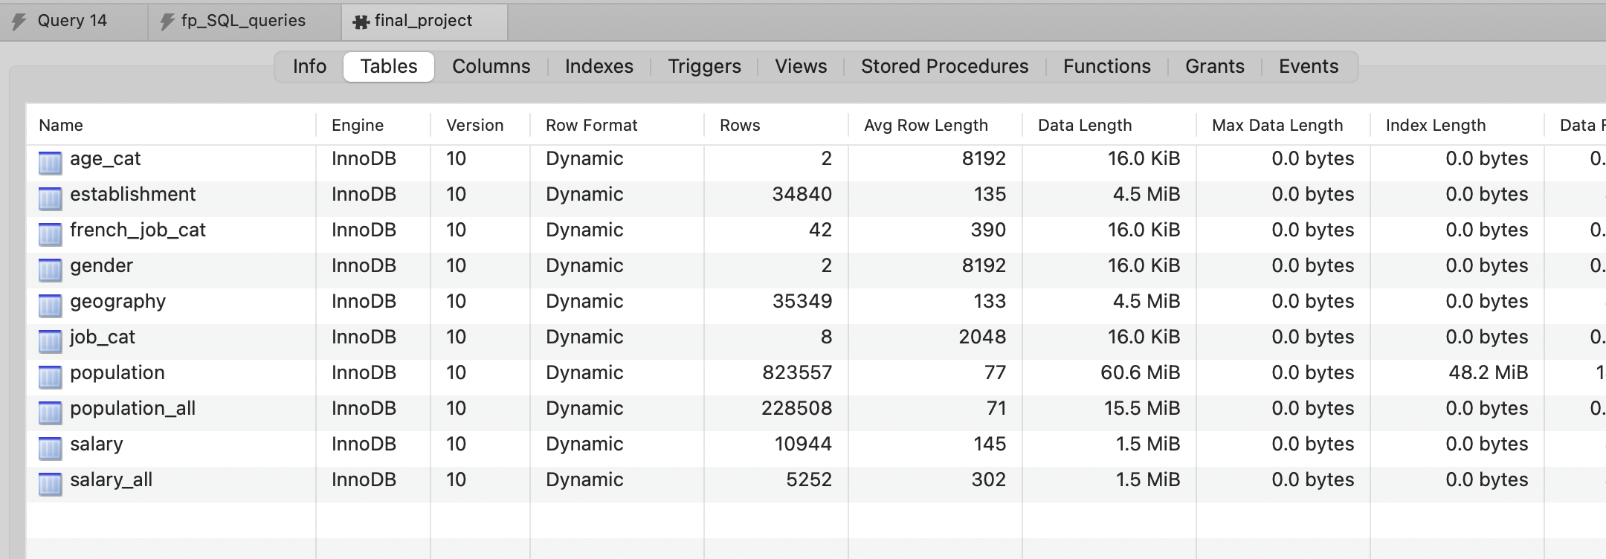

### Entity-Relationship Diagram (ERD)

Our Entity-Relationship Diagram (ERD) provides a visual representation of the database schema, illustrating the relationships between different entities within the database. In our project's ERD, we have several tables representing various aspects of the data, including population demographics, salary information, geographical data, job categories, and women's representation in managerial positions.

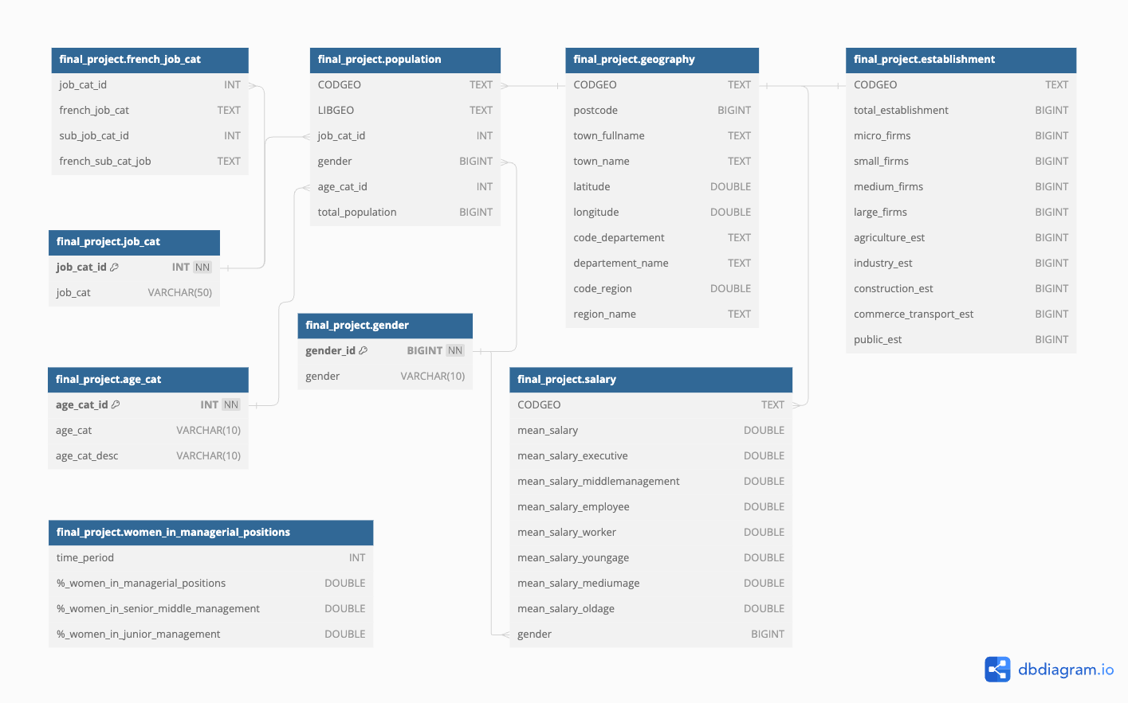

### Insights from the data collected through mySQL

Using MySQL queries to gather insights from the data collected :

#### Query 1 – Pearson correlation between establishment and population for EDA

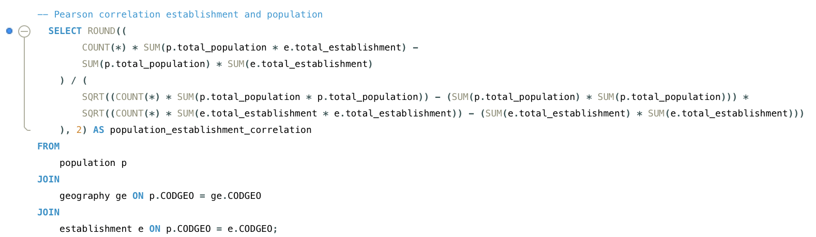

* Result :

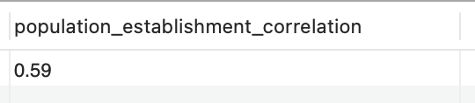

As we said in the EDA part, the number of establishments and the total population is correlated.

#### Query 2 – View of the average gender pay gap by department to integrate in Tableau

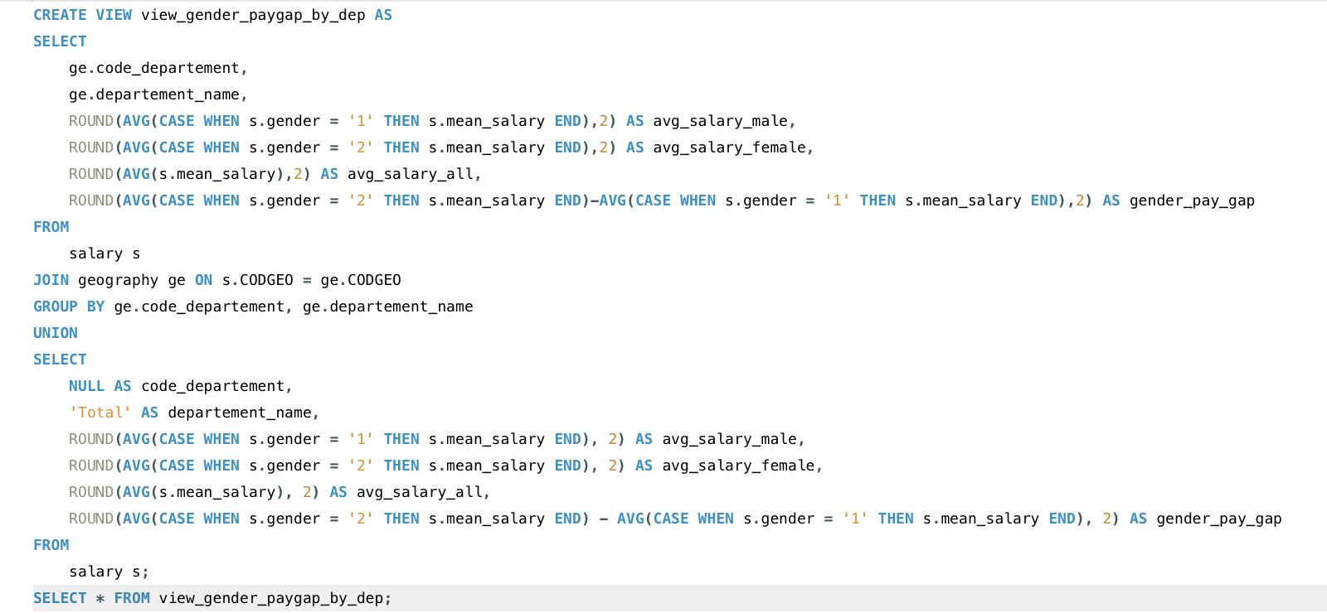

* Result :

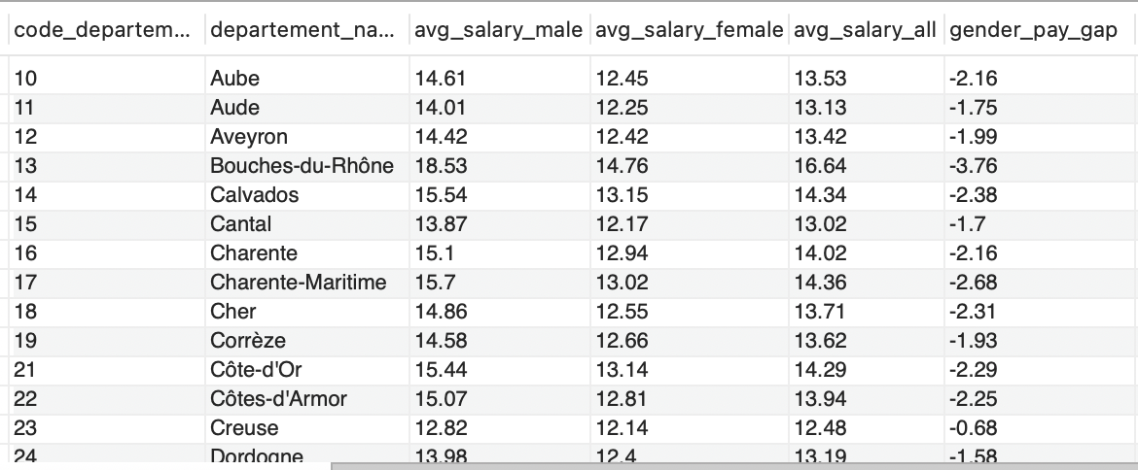

We have exported this view as a CSV to import it on Tableau for our visualization on gender pay gap.

#### Query 3 – View of population and salary data by department and gender to integrate to our API for the 1st endpoint

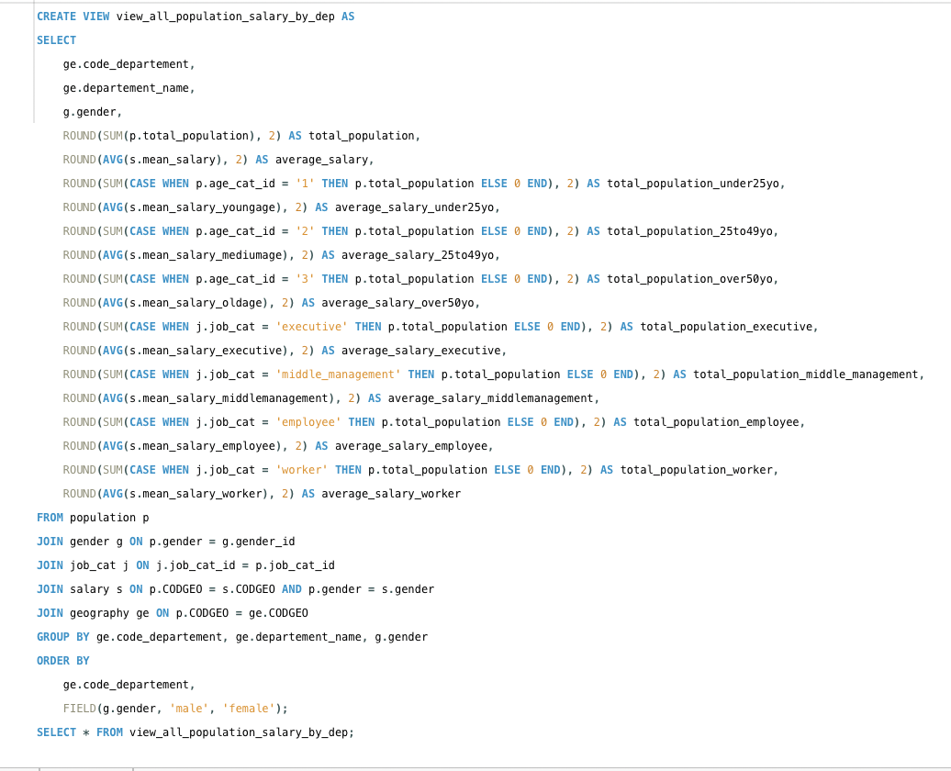

* Result :

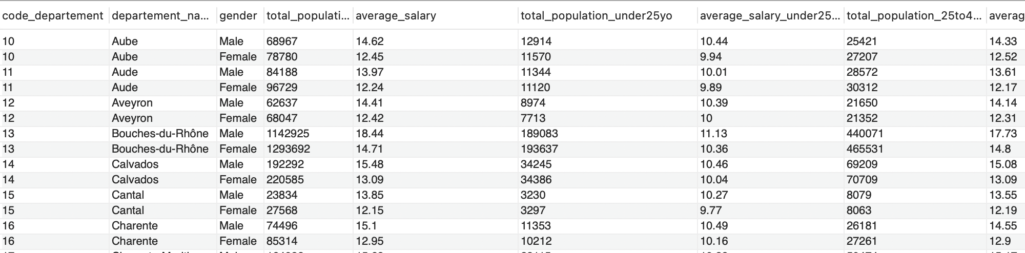

We have used this view for creating our API to expose our data.

#### Query 4 – salaries, total population, paygap, correlation and firms data by department to integrate in our API for the 2nd endpoint

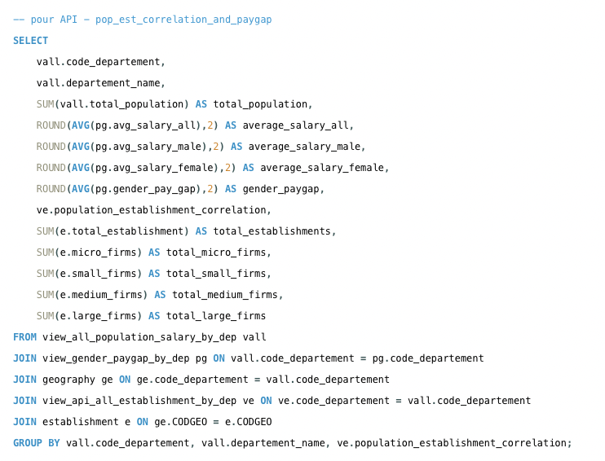

* Result :

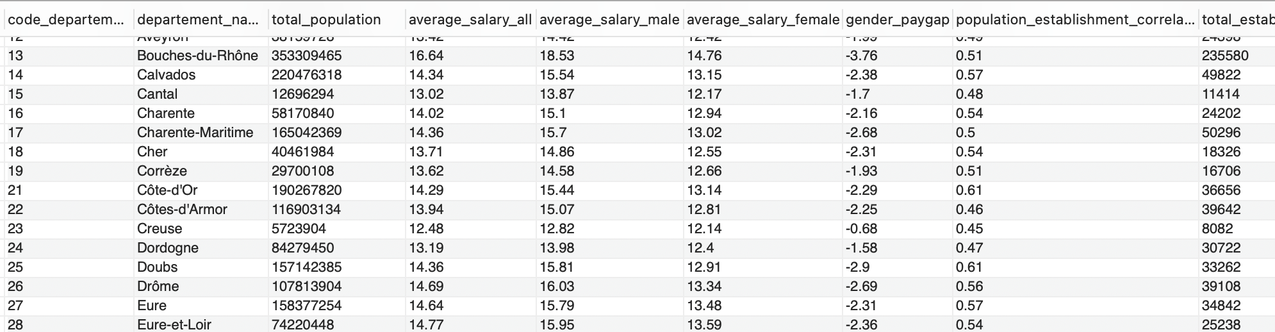

#### Query 5 & 6 – TOP 10 department with higher and lowest gender pay gap for EDA

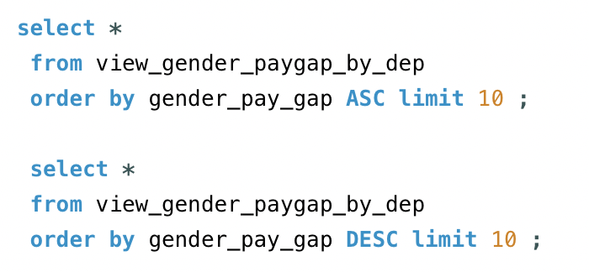

* Result :
* Top 10 - Department with highest pay gap :

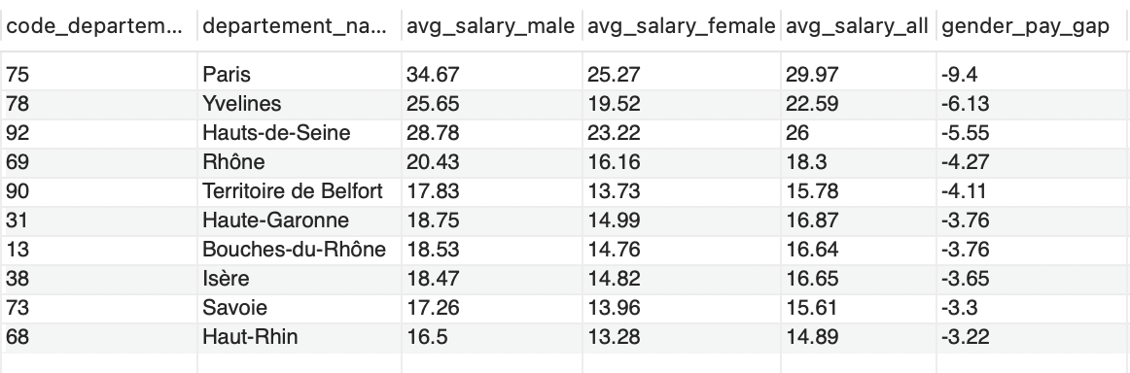

* + Top 10 - Department with lowest pay gap :

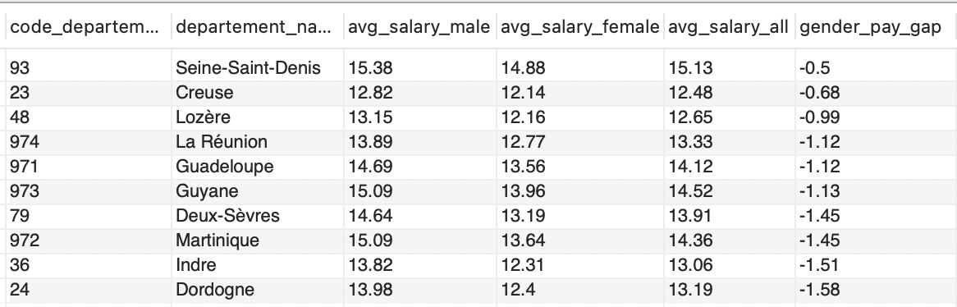

We can see that even the lowest pay gap is still negative. Meaning that the pay gap between female and male is always negative for all departments of France. Women earn less than men everywhere, and gender inequalities is at this highest in the capital at Paris, Ile-de-France.

# API

To expose portion of data from the database I have created an API that allows users, to retrieve specific data on salaries, population by gender, and firms across French department. It provides a valuable resource for analyzing gender disparities and inequalities in France in 2020.

The API has been built using Flask and provides responses in JSON format.

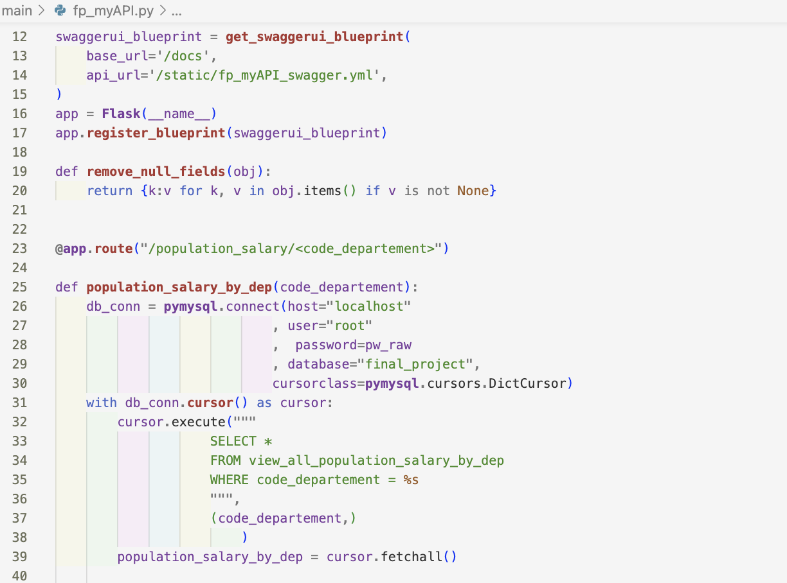

## Swagger

<http://192.168.1.18:8080/docs/> :

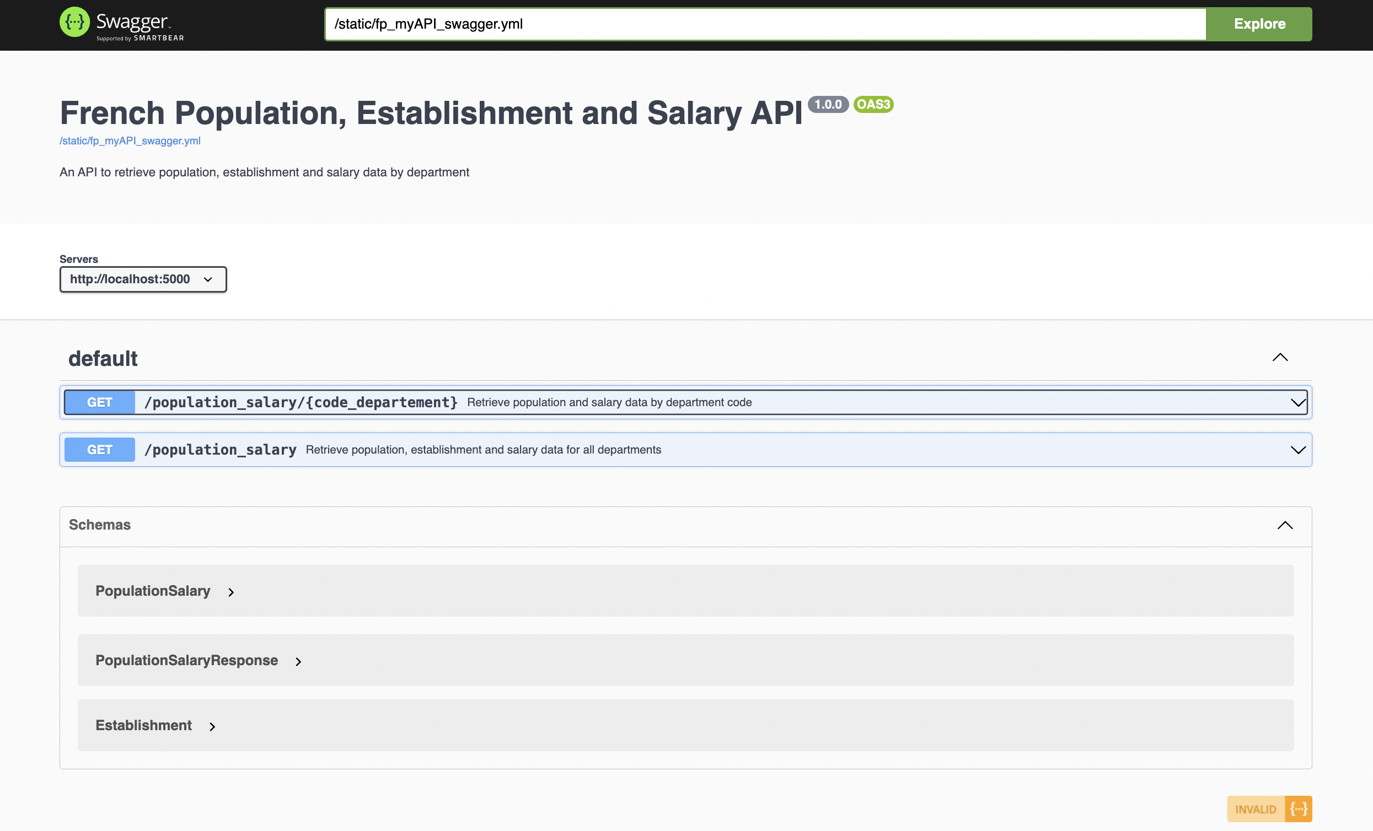

## Endpoints

### Endpoint 1 : /population_salary

<http://192.168.1.18:8080/population_salary> :

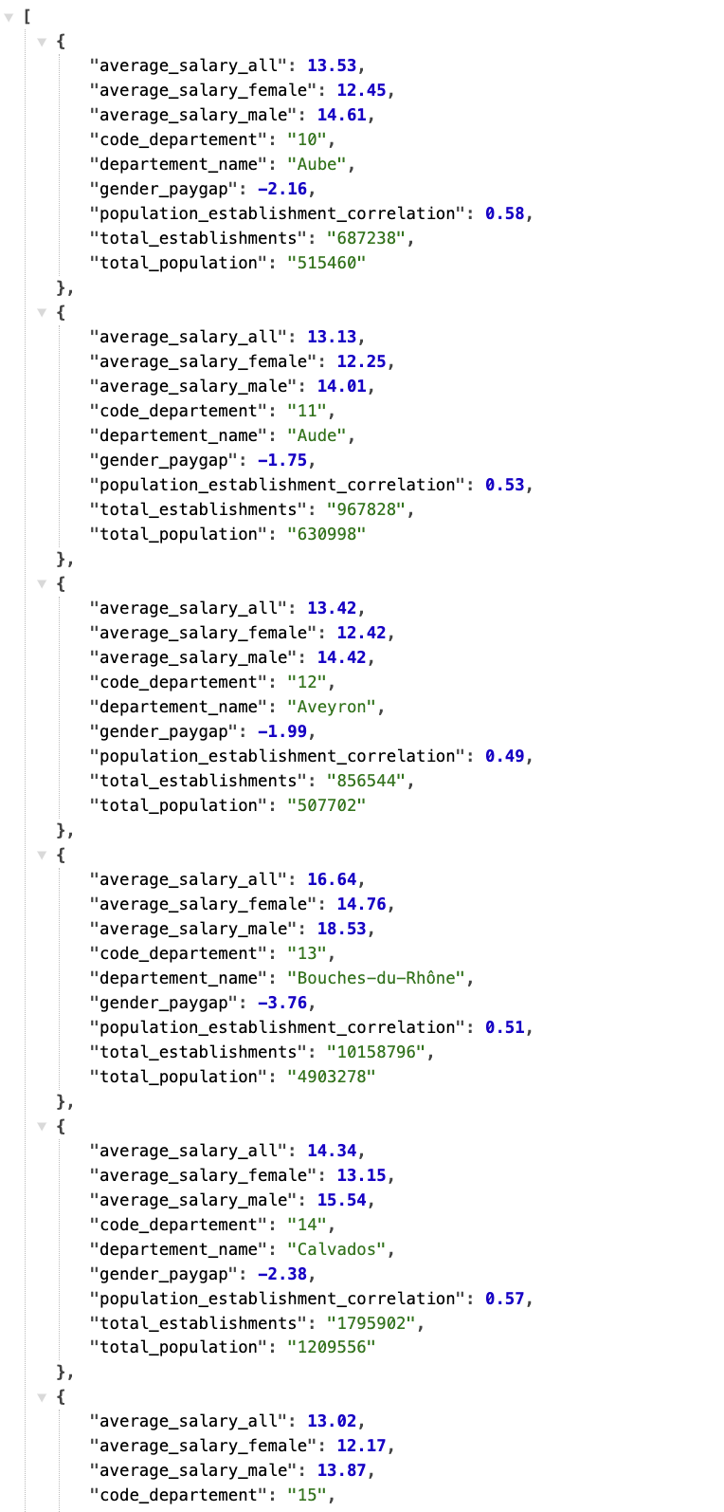

### Endpoint 2 : /population_salary/<departement_code>

<http://192.168.1.18:8080/population_salary/75> :

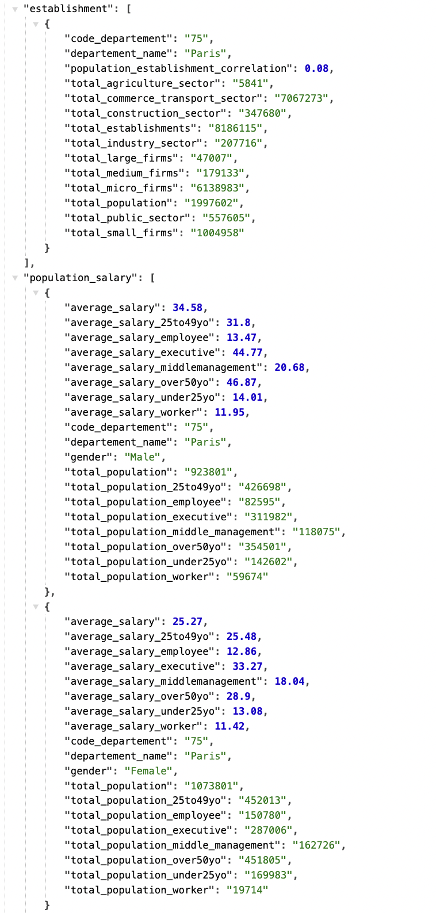

# Conclusion

In conclusion, this project represents a comprehensive exploration of the socio-economic landscape of France through the lens of extensive data analysis. By leveraging datasets from reputable sources such as the French National Institute of Statistics and Economic Studies (INSEE) and employing advanced analytical techniques, we've uncovered valuable insights into population demographics, establishment distributions, salary structures, and job categories across French departments and regions.

Through our analysis, we've identified patterns, trends, and correlations that offer a deeper understanding of societal complexities and economic dynamics within France.

Key findings of the study underscore persistent gender wage disparities and significant underrepresentation of women in managerial roles. These issues highlight systemic inequalities that require targeted policy interventions and societal changes to ensure a more inclusive and equitable labor environment.

Our analysis also provides a foundation for understanding how demographic and socio-economic factors interact across different regions, offering valuable insights for regional planning and development strategies.

By examining data on population demographics, establishment distributions, and salary structures, we've provided valuable insights to inform decision-making and drive socio-economic progress.

Furthermore, the development of an API to access specific data points underscores our commitment to transparency, accessibility, and data-driven decision-making. The API provides a user-friendly interface for retrieving essential information on salaries, population demographics, and firm distributions, empowering stakeholders to conduct further analysis and research to support evidence-based policymaking and advocacy efforts.

As we advance, integrating machine learning techniques stands out as the next strategic step to deepen our analysis and enhance predictive capabilities. This approach will enable us to model potential future scenarios and assess the impacts of various socio-economic policies before their implementation. By forecasting trends and outcomes, machine learning can provide a proactive tool in policy formulation and social planning, ensuring that interventions are both timely and evidence based.

In essence, this project represents a significant step towards understanding and addressing socio-economic challenges in France. By harnessing the power of data and analytics, we've illuminated key insights that can drive positive change and pave the way for a more prosperous and inclusive future for all citizens.

# GDPR

After a thorough assessment of the data collected for this project, I can confidently affirm that no personal data has been utilized in any part of the processes. The sources of the data are entirely public and at a country level, ensuring full transparency and accessibility. Therefore, this project adheres to the guidelines and principles of the General Data Protection Regulation (GDPR).

# References

* Github repository : <https://github.com/steprag/fp_finale_project>
* Flat files sources :
  + <https://www.insee.fr/fr/statistiques/4991205>
  + <https://www.insee.fr/fr/statistiques/2021266>
  + <https://www.insee.fr/fr/statistiques/7631680?sommaire=7632456>
  + <https://www.data.gouv.fr/fr/datasets/communes-de-france-base-des-codes-postaux/>
* SDG API link : <https://unstats.un.org/sdgapi/swagger/#!/Target/V1SdgTargetDataGet>
* Target for the API : <https://sdgs.un.org/goals/goal5#targets_and_indicators>
* Webscraping source :
  + <https://fr.wikipedia.org/wiki/Professions_et_cat%C3%A9gories_socioprofessionnelles_en_France>